Product Symbols (HHPS)

{AB.Sc24.A.K.1.i} {AB.Sc24.A.K.1.ii} {AB.Sc24.A.S.2.vi} {AB.Sc24.A.S.3.vi}

Name: Date:

This worksheet will help you review the Hazardous Household Product Symbols (HHPS) from
Section 1.3.
- Review the symbols that can be used on hazardous products used around the house.
- Review the shapes and colours that can be used around each symbol.
- Then answer the What Did You Find Out? questions.
- File this worksheet in the correct section of your notebook.

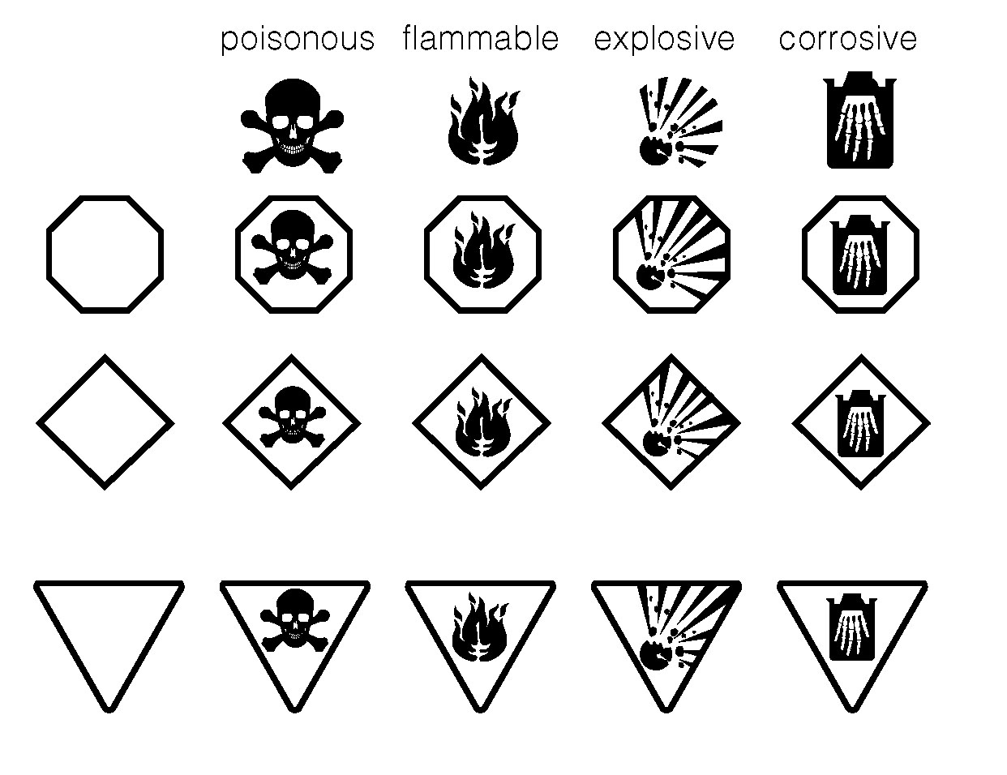

What Did You Find Out?
1. Hazardous household products are generally placed in one of the four groups. List these groups.

CHAPTER 1 |  | BLM 1–6
REINFORCEMENT | Hazardous Household
Product Symbols (HHPS) (continued)

2. One of three different shapes is placed around the warning symbol. The shapes each have a meaning and colour. Identify each shape, its colour, and what it means.

Shape | Colour | Meaning
 | red
 |  | warning

3. Identify the HHPS symbol you would expect to find on the label of each of the products below. What shape would you expect around that item?

Product | HHPS | Shape
1. gasoline for a lawn mower | (a)
 | (b)
2. hydrochloric acid toilet cleaner
3. household ammonia cleaner
4. propane bottle for camp stove | (a)
 | (b)
5. acetone nail polish remover
6. mouse poison
7. butane for a curling iron | (a)
 | (b)
8. pesticide container
9. chlorine bleach
10. methanol (rubbing alcohol)

CHAPTER 1 |  | BLM 1–6
REINFORCEMENT | Hazardous Household
Product Symbols (HHPS) (continued)

4. Explain why the following practices are dangerous.
(a) mixing chlorine bleach with ammonia when cleaning the bathroom

(b) using an alcohol-based cleaner to remove stains from clothing and then putting the clothing into a clothes dryer

(c) storing a propane tank directly underneath a barbecue on a wooden deck

(d) placing a small amount of pesticide in an unlabelled soft drink bottle

(e) using bare, unprotected hands when washing a toilet bowl with an industrial strength cleaner that contains 23 percent hydrochloric acid

(f) dumping used car oil into a storm sewer

