Graphing Lines & Killing Zombies
Easy Mode
Instructions:
- Graph each linear equation below on the zombie-filled grid on the next page. Use a ruler to draw each line all the way across the grid and label each line with its corresponding number.
- Each line should run through a single zombie only. Write the number of the line next to the picture of the zombie it went through in the space below the grid.

Linear Equations:

- $y=x+1$ 2. $y=1$ 3. $x=5$

4. $y=3x-5$ 5. $y=-x-5$ 6. $y=-3x$

7. $y=-\frac{1}{2}x+4$

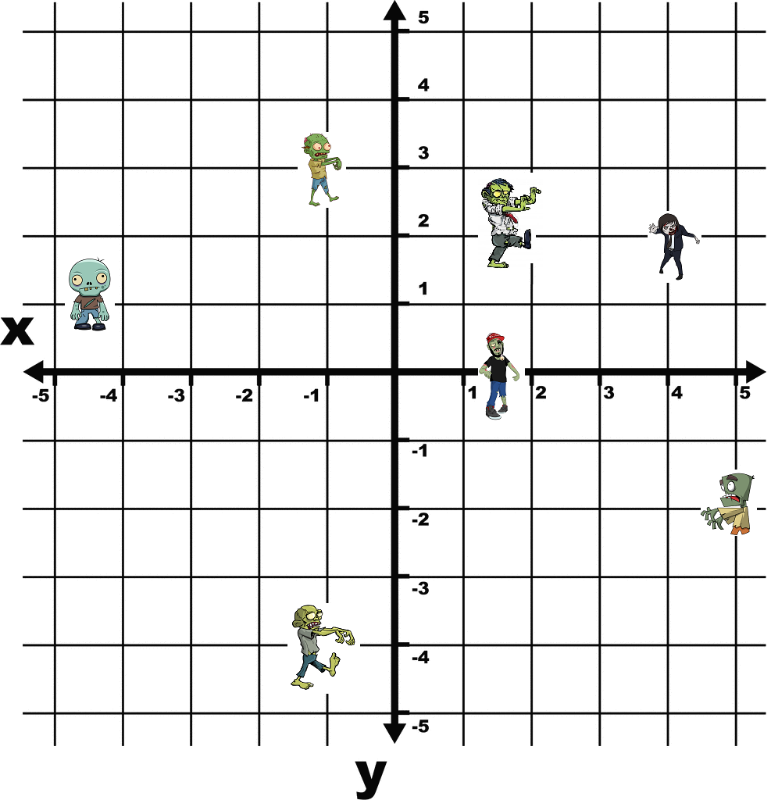
Graph each line and match it to the zombie that it “kills”. To kill a zombie the line must run through any part of its body.
Each line should only kill one zombie. If you kill more than one you were not precise enough.

