Graphing Linear Functions Investigation

Complete the table of values for each linear function, then answer the questions that follow.

- $y=2x+1$
- $y=3x-2$
- $y= -x+5$
- $y= -4x-3$

$$x$$ | $$y$$ |  | $$x$$ | $$y$$ |  | $$x$$ | $$y$$ |  | $$x$$ | $$y$$
$$-2$$ |  |  | $$-2$$ |  |  | $$-2$$ |  |  | $$-2$$
$$-1$$ |  |  | $$-1$$ |  |  | $$-1$$ |  |  | $$-1$$
$$0$$ |  |  | $$0$$ |  |  | $$0$$ |  |  | $$0$$
$$1$$ |  |  | $$1$$ |  |  | $$1$$ |  |  | $$1$$
$$2$$ |  |  | $$2$$ |  | 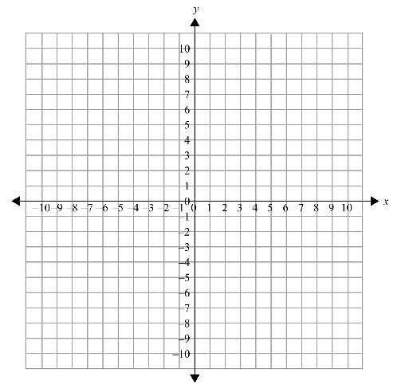 | $$2$$ |  |  | $$2$$

b)

- (a) Find a connection between the constant number at the end of each equation and one of the entries in the corresponding table of values.

(b) Find a connection between the constant number at the end of each equation and the corresponding graph.

- (a) Find a connection between the coefficient in front of the $x$ in each equation and the pattern in the corresponding table of values.

(b) Find a connection between the coefficient in front of the $x$ in each equation and the patterns in the corresponding graph.

- What is the connection between the sign of the coefficient in front of the $x$ in each equation and the direction of the line on the corresponding graph?

