Golf Ball Bridge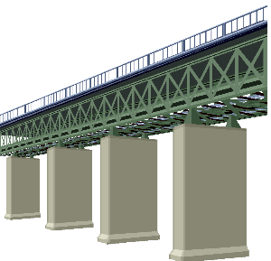

Designers face many challenges when planning a new project. In this activity you will test your ability to design a bridge that meets a set of specifications.

You will show me during this activity that you….
Can identify criteria or specifications for a structural design
Can fulfil criteria and specification for a job
Can propose alternative solutions to a practical problem, select one, and develop a plan
Can work collaboratively

Task/Challenge
Working in teams, plan and build a free-standing frame structure (golf Ball Bridge) that meets all the design specifications outlined below:

- Free standing (Not attached to anything)
- Span 30cm
- 5cm height
- Support a golf ball as it rolls across the bridge

Materials
- 20 straws
- 15 paper clips
- 60cm of masking tape
- Scissors
- Ruler
- Golf Ball

