UNIT A – SECTION 1

1. Species

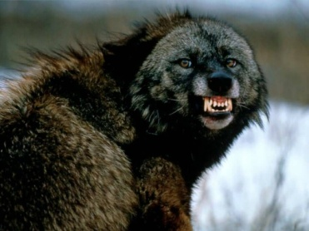

1. Biological Diversity

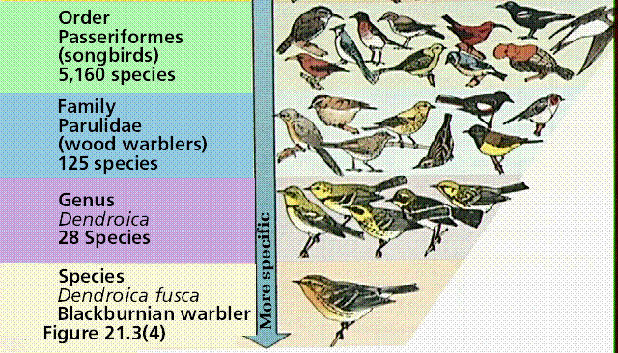

1. Ecosystem

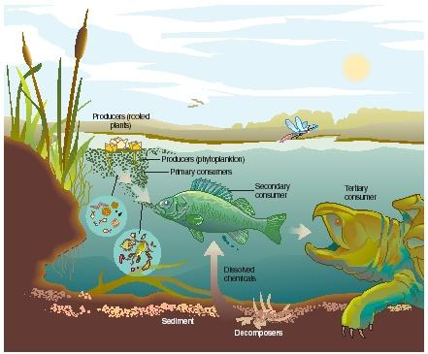

1. Population

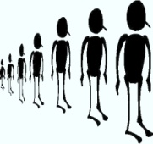

1. Community

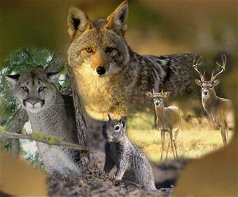

1. Genus

Wolf – Canis

1. Kingdom

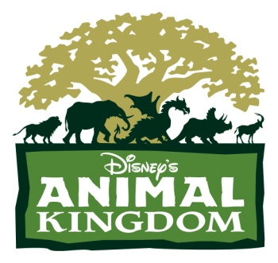

1. Phyla

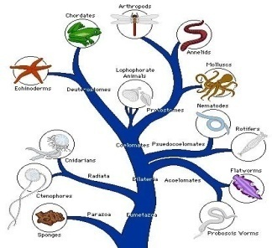

1. Subphyla

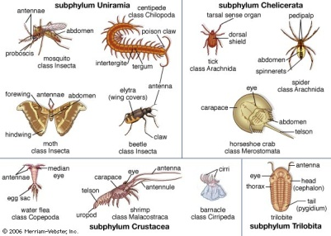

1. Classes

White Spruce – Pinopsida

1. Orders

White Spruce – Pinales

1. Families

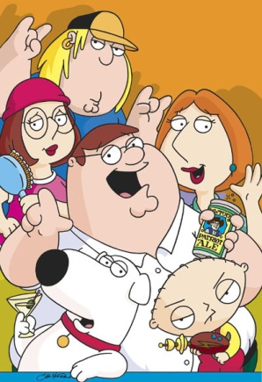

1. Genera

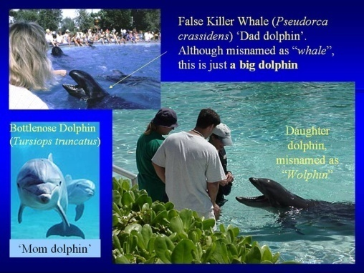

1. Symbiosis

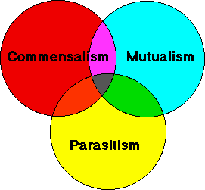

1. Commensalism

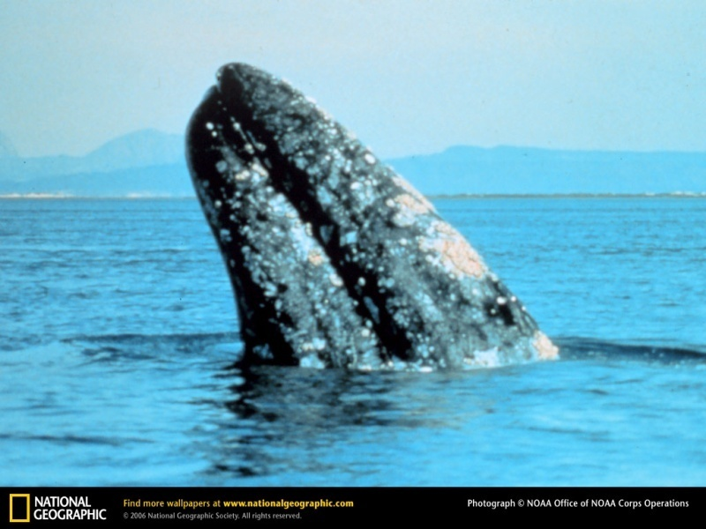

1. Mutualism

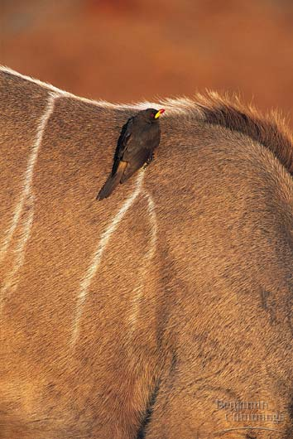

1. Parasitism

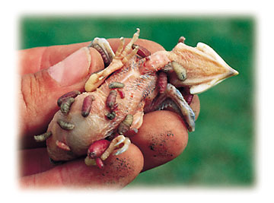

1. Niche

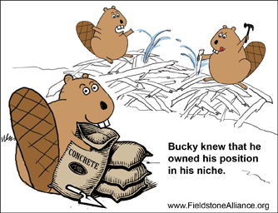

1. Interspecies Competition

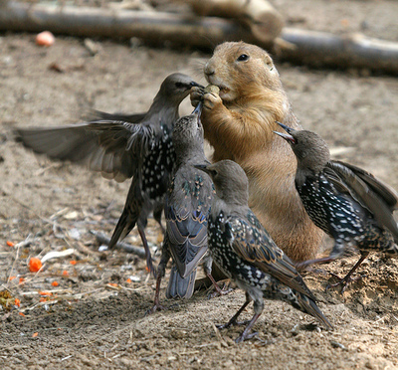

1. Resource Partitioning

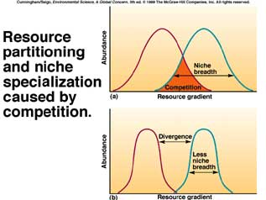

1. Variability

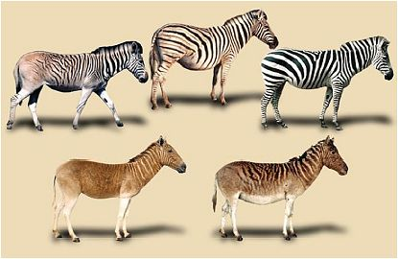

1. Natural Selection

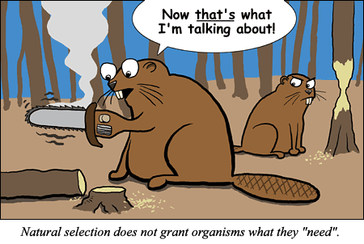

UNIT A – SECTION 2

1. Heritable Characteristic



1. Non-Heritable Characteristic

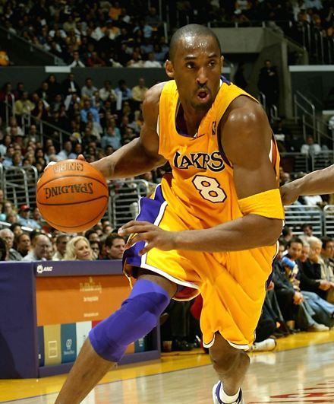

1. Discrete Variation

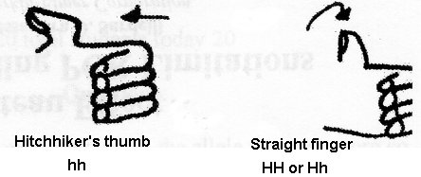 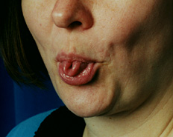

1. Continuous Variation

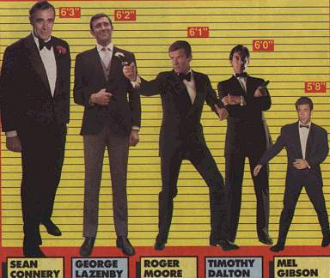

1. Asexual Reproduction

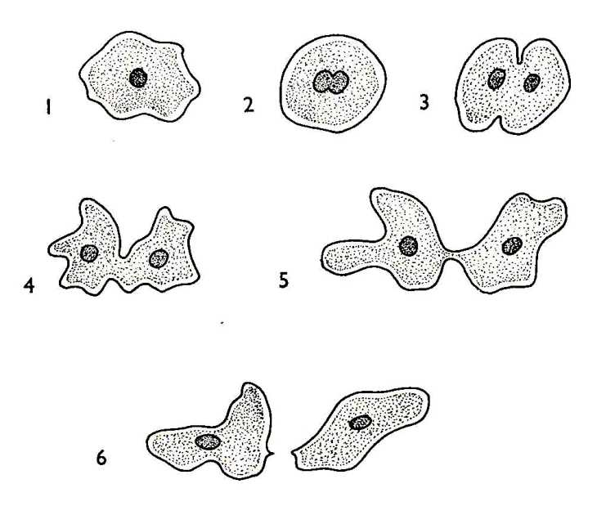

1. Binary Fission

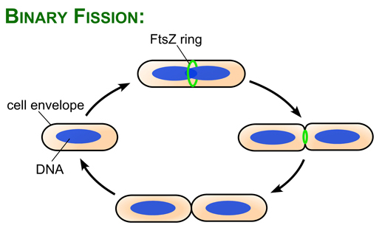

1. Budding

[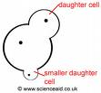](http://scienceaid.co.uk/biology/microorganisms/images/budding.jpg)

1. Spores

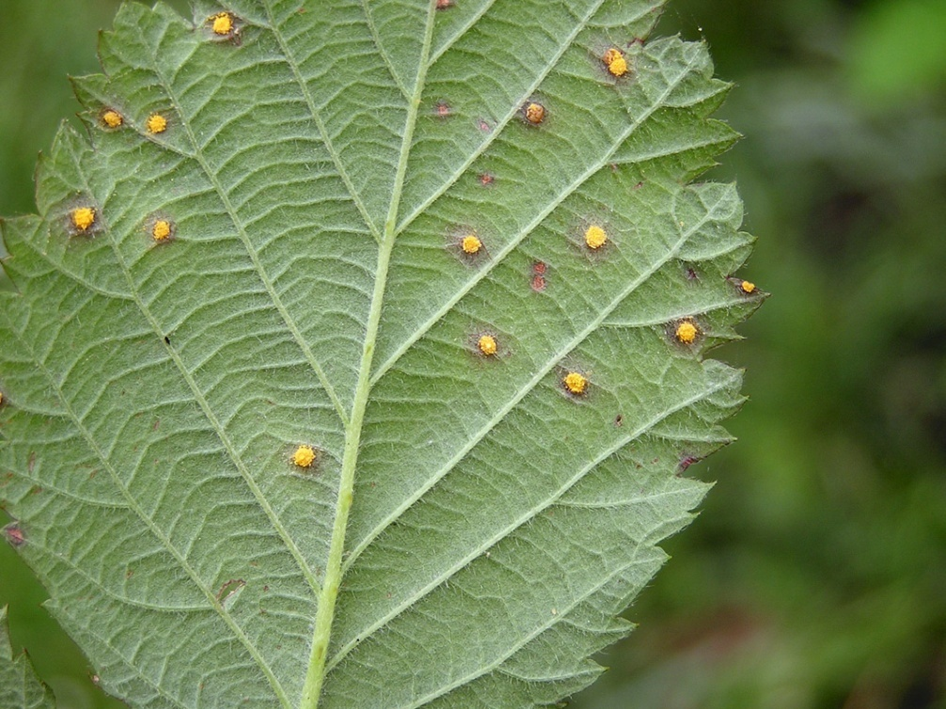

1. Vegetative Reproduction (Grafting)

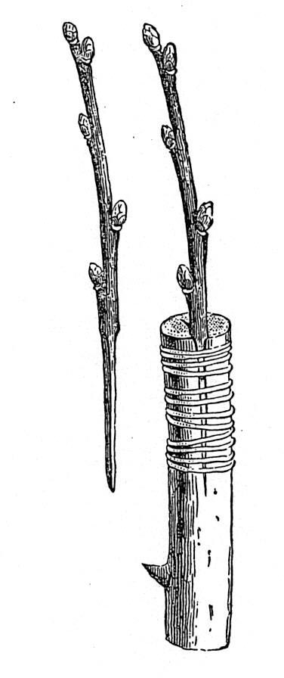

1. Sexual Reproduction

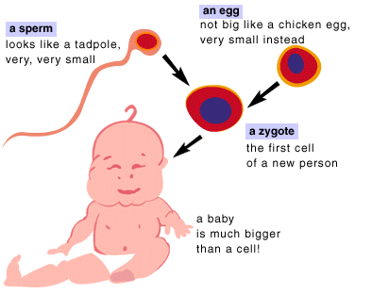

1. Gametes (Egg & Sperm)

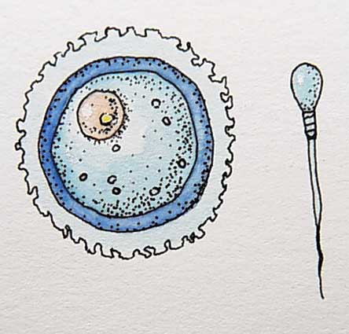

1. Fertilization

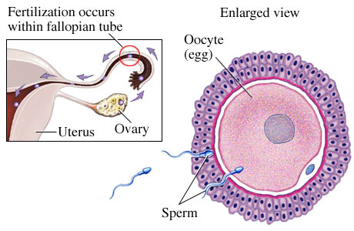

1. Zygote

[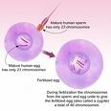](http://images.google.com/imgres?imgurl=http://zakstar.files.wordpress.com/2008/05/zygote.jpg&imgrefurl=http://zakstar.wordpress.com/2008/05/07/pro-lifers-with-the-evidence-against-them-they-return-to-their-roots/&h=300&w=300&sz=99&hl=en&start=2&um=1&usg=__Sg9WCB-1BU_7Z72Y1YAMlW5p1S0=&tbnid=H3M7IOBXKOTt4M:&tbnh=116&tbnw=116&prev=/images?q=zygote&um=1&hl=en&sa=G)

1. Cleavage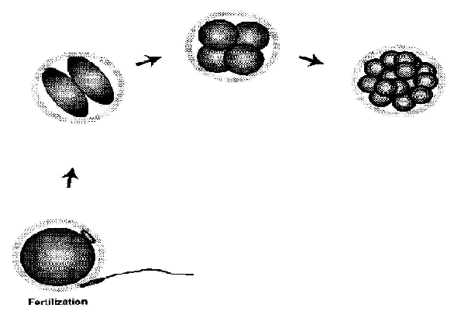
2. Embryo

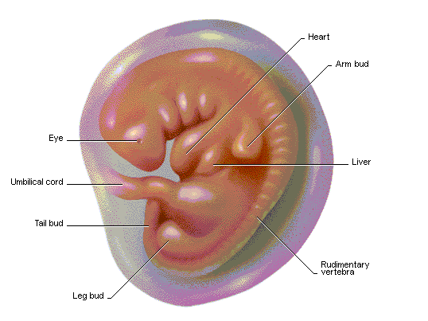

1. Sexual Reproduction in Plants

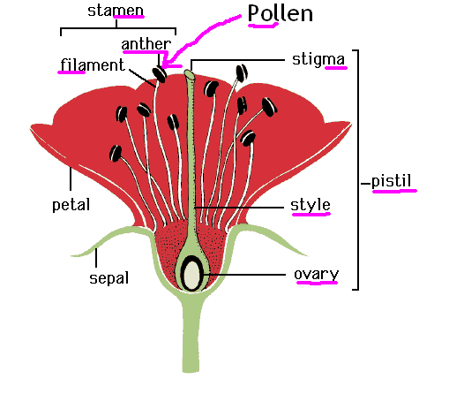

1. Pollination & Fertilization

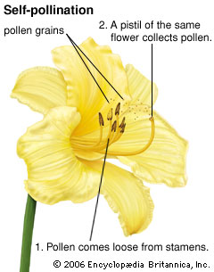

1. Cross Pollination & Cross Fertilization

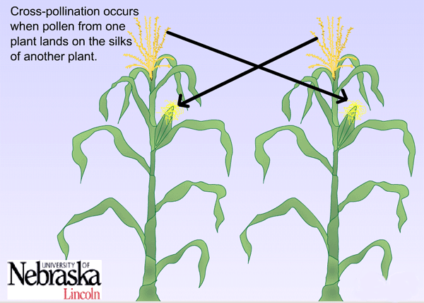

UNIT A – SECTION 3.0

1. DNA (Watson & Crick)

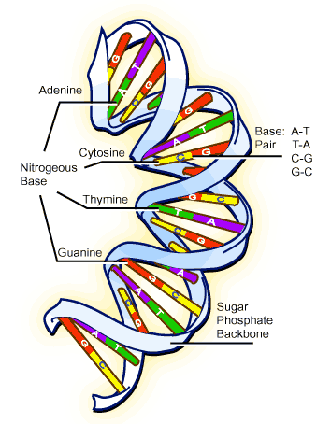

1. Genetic Code

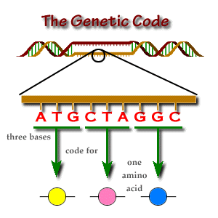

1. Chromosomes

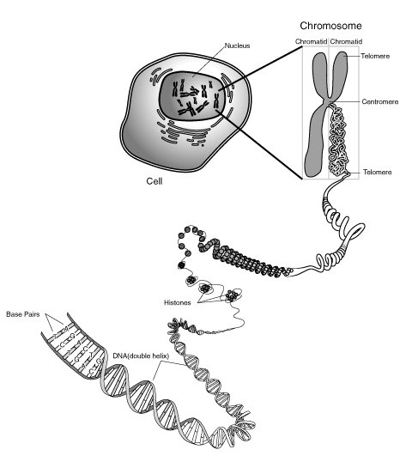

1. Human Chromosomes

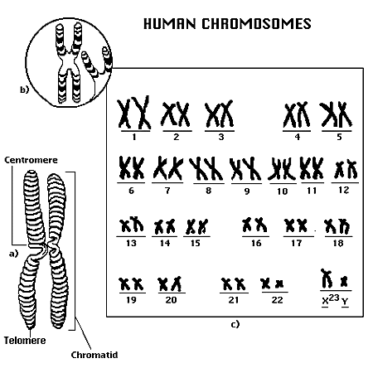

1. Genes

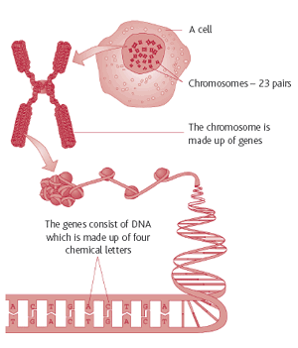

1. Genes

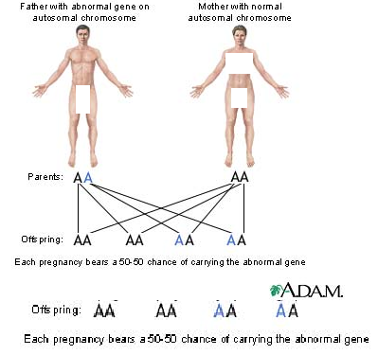

1. Genes 3

In the center of every cell in your body is a region called the nucleus. The nucleus contains your DNA (deoxyribose nucleic acid), which is the genetic code you inherited from each of your parents. The DNA is ribbon-like in structure, but normally exists in a condensed form called chromosomes. You have 46 chromosomes, which are in turn comprised of thousands of genes. These genes carry specific instructions that tell cells how to work, control our growth and development, and determine what we look like and how our bodies work. They also play a role in the repair of damaged cells and tissues. Each person has more than 30,000 genes, which are made up of DNA . You have 2 copies of every gene, 1 inherited from your mother and 1 from your father.

1. Genes 4

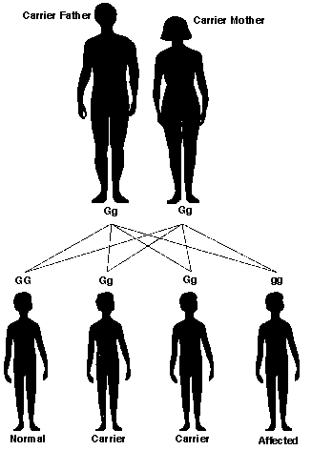

1. Alleles 1

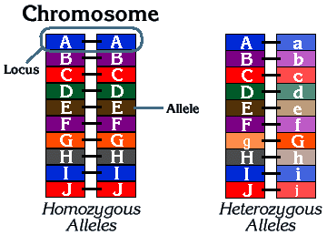

1. Alleles 2

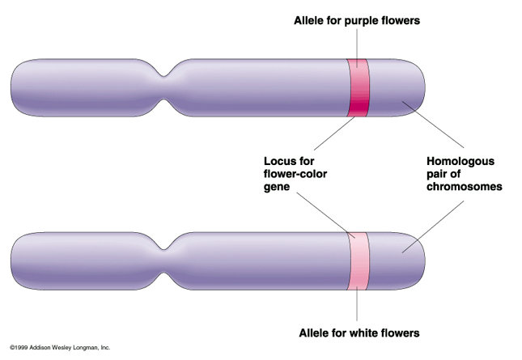

1. Alleles 3

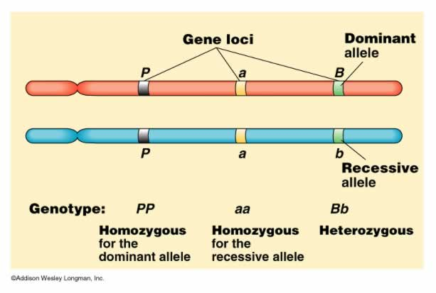

1. Mitosis

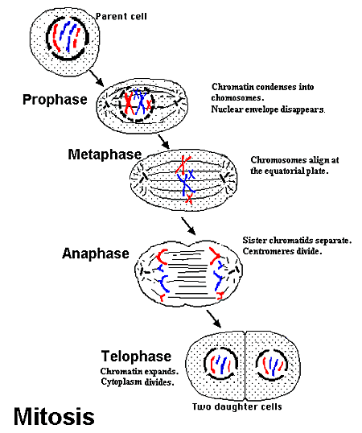

1. Meiosis

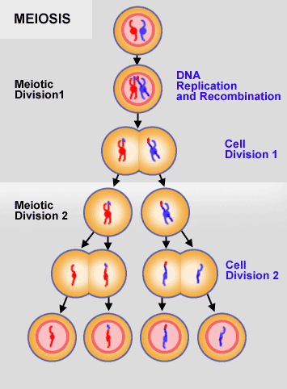

1. Meiosis 2

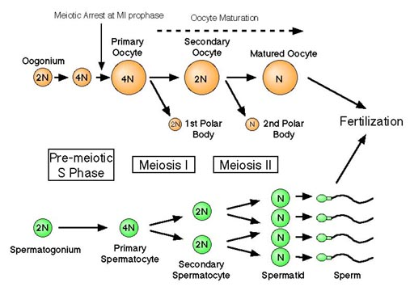

1. Traits

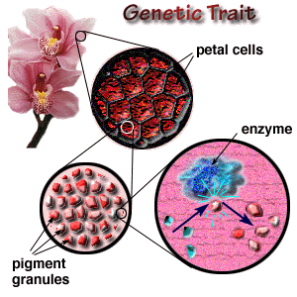

1. Traits 2

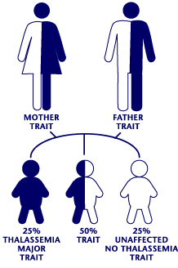

1. Traits

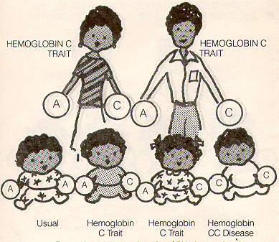

1. Purebred

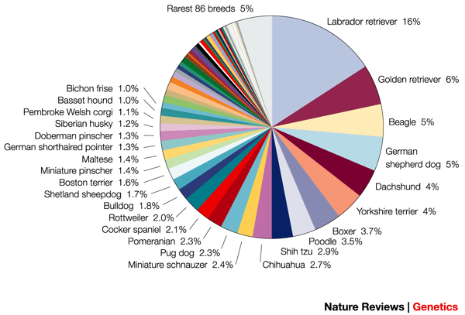

1. Hybrid

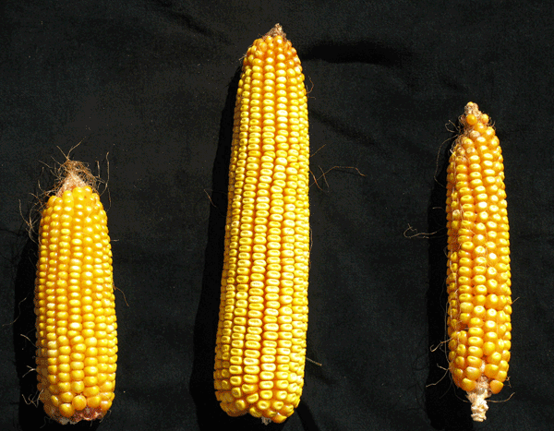

1. Dominant Trait

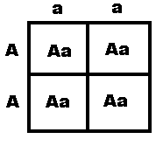

1. Recessive Trait

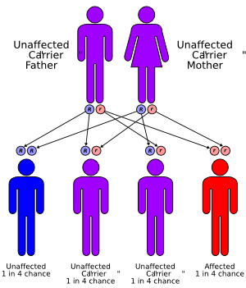

1. Incomplete Dominance

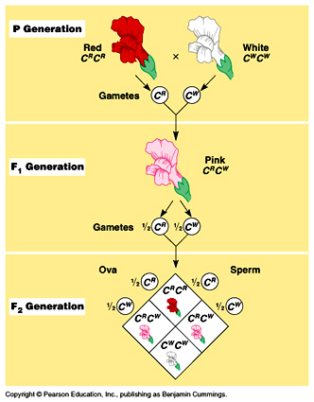

1. Environmental Factors

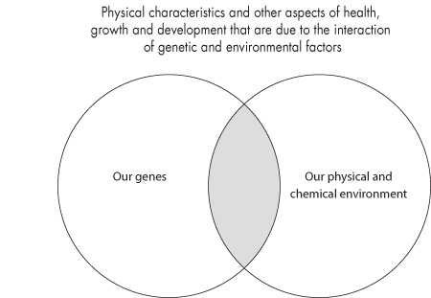

1. Extinct

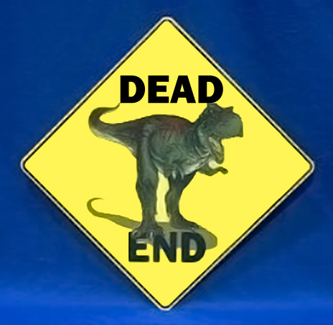

1. Extirpation

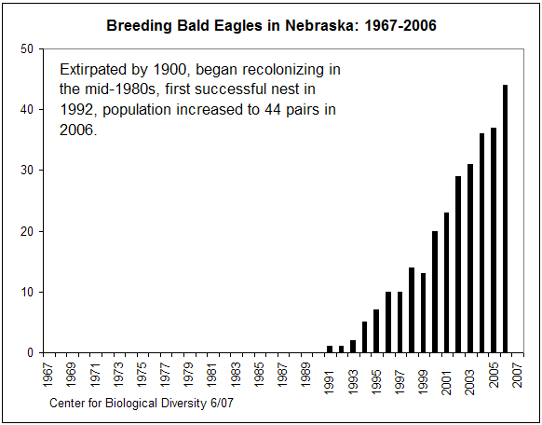

1. Endangered Species

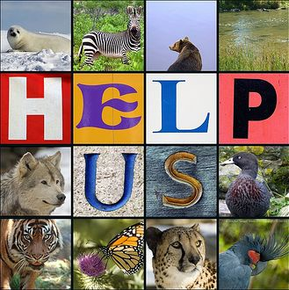

1. Threatened Species

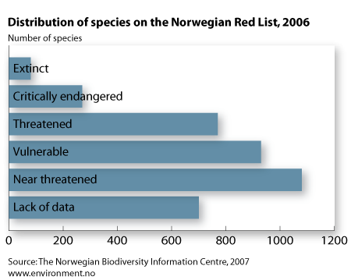

1. Special Concern

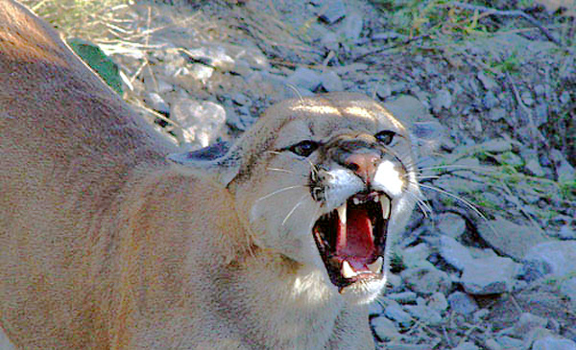

1. Overspecialization

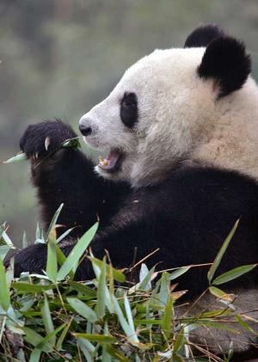

1. Habitat Destruction

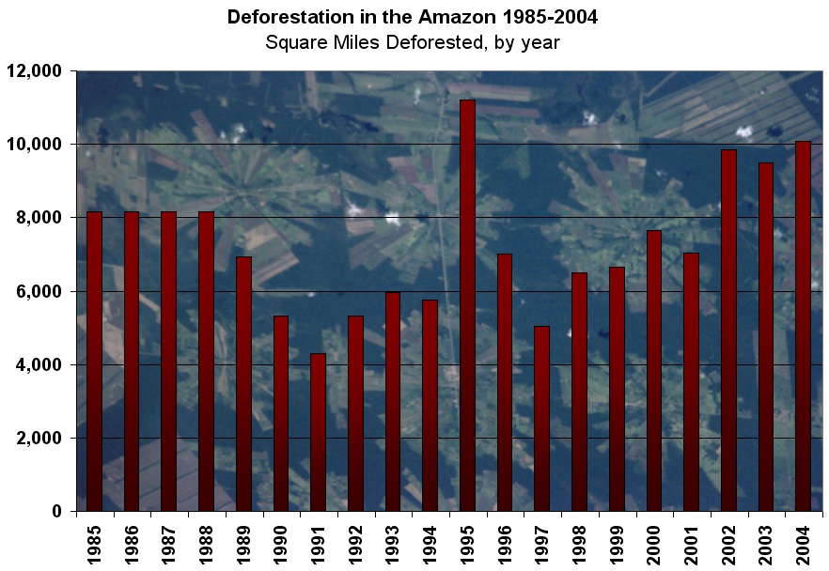

1. Artificial Selection

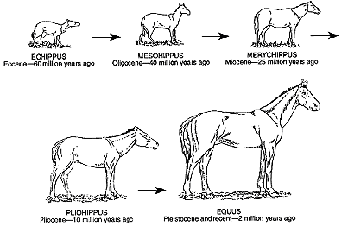

1. Biotechnology

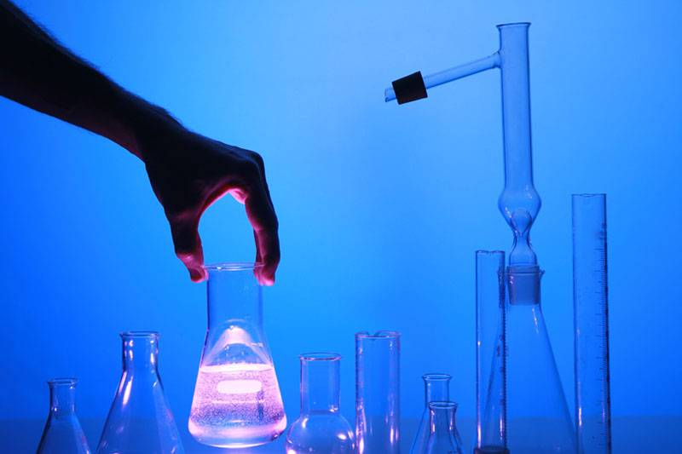

1. Clone

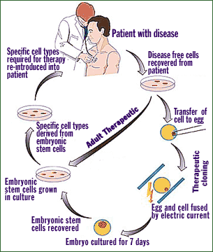

1. Clone – 2

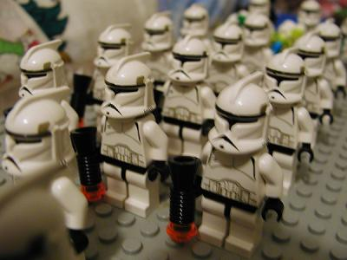

1. Artificial Insemination

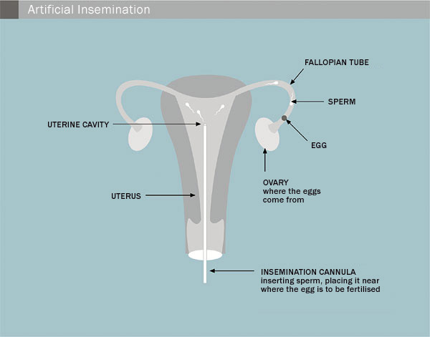

1. Artificial Insemination

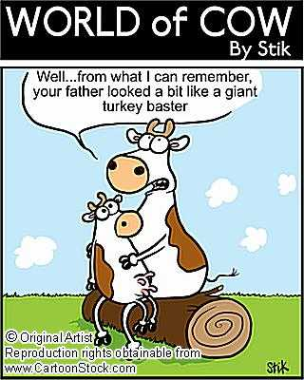

1. In-Vitro Fertilization

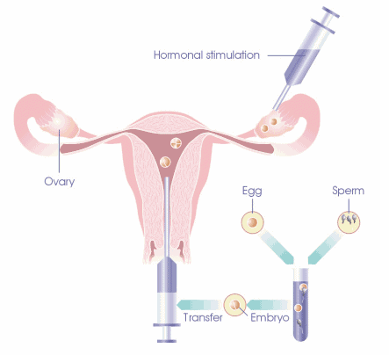

1. Genetic Engineering

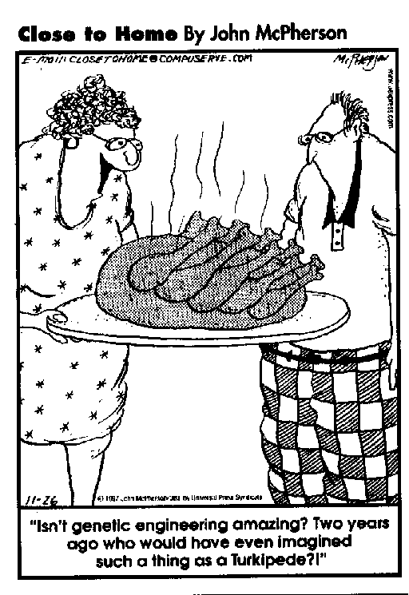

1. In-Situ Conservation

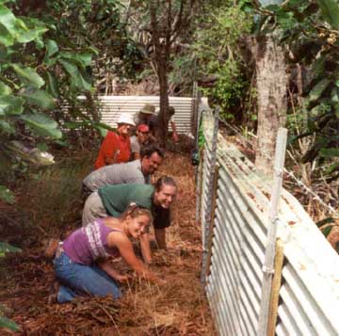

1. Ex-Situ Conservation

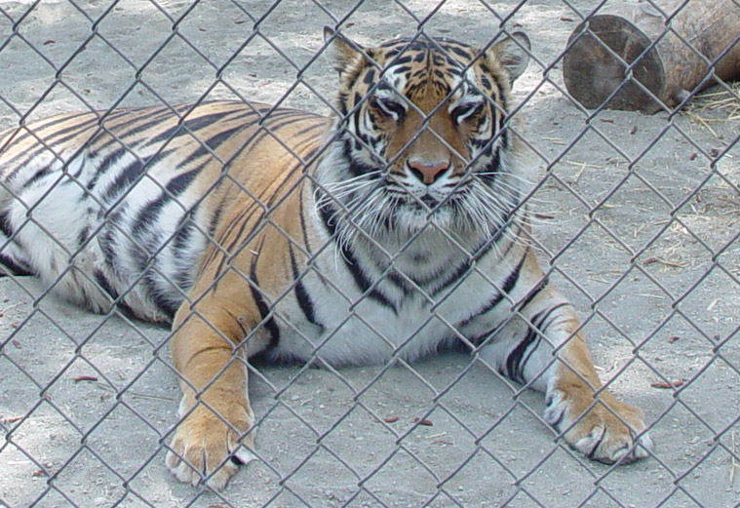

1. Wagner Natural Area

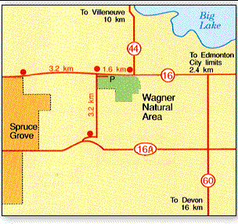

1. COSEWIC

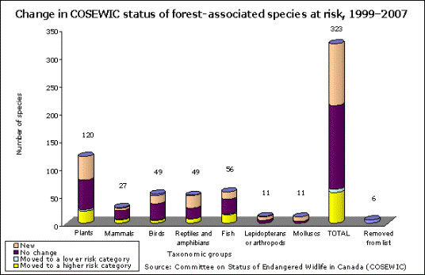

1. Exotic Species

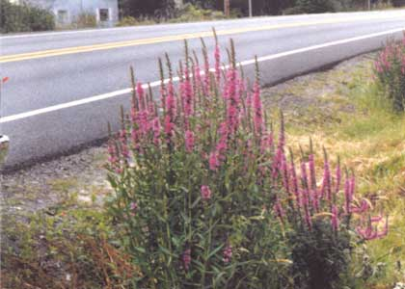

1. Seed Bank

