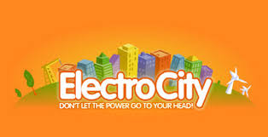

A Thorough Look at the Online Educational Game

Directions
In Electrocity you act as the mayor of a newly founded town. Your goal can be many and may include having no environmental impact, having the highest population of all your friends or to have all your citizens be happy for the lifetime of your town. To begin however you first need to know how to play the game.

Save Game
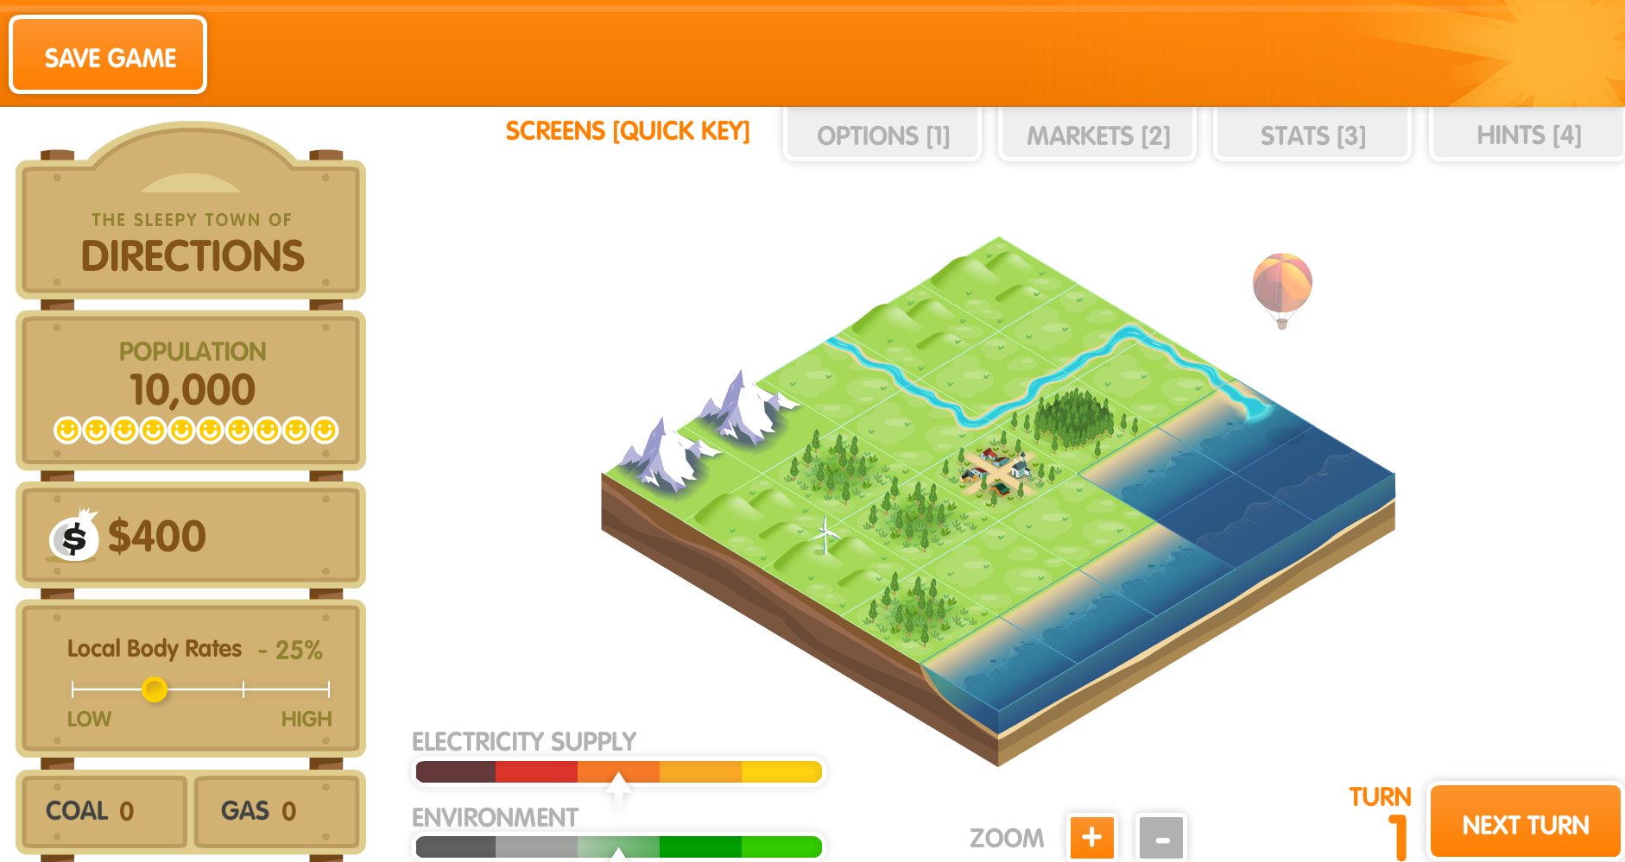
The HUD (Heads up Display) Is the first piece that draws your eyes. This is the series of buttons and levels around the interactive island. The top left is the name of your town. For this paragraph we are using

Taxes

Money

Options/Info Bar

Resources

Population

Town Name

Next Turn

Electricity and Environment levels

Zoom

the name Directions for simplification. Underneath of town name is the population the default beginning population is ten thousand but through tourism and constructing tiles that bring people in, it will rise rapidly. Money is the simplest and essentially explains itself. The Local body rates acts as taxes giving you more money the farther right you slide and less the farther left. The resources are coal on the left and gas on the right. These are resources that can be harvested from prospected tiles or purchased from the market in the options bar. Gas and coal have three uses, coal and gas are used on the market to increase money and to heat their coal/gas turbines to increase power production and gas can be used in the town options to heat homes which then uses less power. These boxes essentially count how many gas and coal you own. The levels show you the ratio of power consumption and production and the other meter shows your environmental impact, this is the ratio of pollution and how much you decrease pollution. Zoom, next turn and save game all do the action they say on the button. Zoom zooms in on four tiles and can be moved by clicking the arrows on the side. Next turn goes to the next turn and gives you your income and energy produced. Save game allows you to play the
game at a later date.
Options/ Info Bar
This bar contains four tabs: options, markets, stats and hints. Each bar is assigned its own hotkey (one through four) and his is to ensure speedy access. The options bar gives you three options you can turn on and off. The first one is a build confirmation screen. This gives you the option to turn the confirmation screen outlining pros and cons, costs and income. It’s recommended for new players to keep this on. The second is events. This gives you a summary of events at the end of that turn such as unhappiness or too much pollution. You can see these in real time in the stats tab. The third option is the auto-buy power shortfall. This automatically purchases power you required but were unable to generate. If this is turned off it will still give you the option to purchase the power. The second tab is markets and is the most important. This gives you a place to purchase or sell coal and gas to increase money and to use in turbines or to heat homes in the programmes bar. This is an important piece to keep in mind and is commonly overlooked. The third tab is the stats tab and just gives you info on your city and events from your population. Events such as pollution and unhappiness shows up here on that turn. The fourth is hints and is only useful on a first or second playthrough for new players. This Bar should be used constantly throughout your playthrough as the market is constantly changing and a profit can be made as well as using the event info to improve your city.
Electricity and Environment bars
The electricity bar shows the ratio of power used to power generated. When the arrow is in the yellow spot it is at the best ratio it can be. When it’s at the dark red, you are in a position where you are going to have to purchase your energy and will decrease the happiness of your population.
In this game the environment’s effect is decreasing the happiness of your population. The bar works in the sameway as the electricity with the green being the best ratio of pollution to decreasing of pollution, and grey being the worst.

Controls
The essential buttons for the game are the tax bar and the next turn buttons. The part of the game that all visual animations happen is the landmass, the five by five tile platform in the middle of the screen. Each tile can be accessed by clicking on it. The options that pop up are unique to each tile, the city has it's about and programmes tabs. The about tab gives stats and your population while the programmes tabs allows you to invest small amounts of money to decrease the strain of power output and environmental impact. Natural or empty tiles and buildings have the about, build and stats bar. The about tab gives you the same options as the city and the stats bar gives specifics. The build tab allows you to construct new buildings or to upgrade your existing ones. This is extremely important as the land is only five by five requiring you to keep in mind space management. Different buildings can be constructed but some are only able to be built on specific resources or tiles. Constructions such as whale watching, the marine generator and drilling platforms are only able to be built in the sea, while the ski hill and resort are the only constructions able to be built on the mountains. When beginning a game you must use every turn a wisely as you can. This ensures your plans are kept within the one-hundred fifty turn limit. The next turn also gives you your income allowing you to construct buildings the next turn and shows you the happiness of your citizens showing you how to improve the feelings of your citizens.
How to start your game
The beginning of the game is important as it is the point you are vulnerable to bankrupt because you have a small city which gives you far less income than any other point. Once you have passed the beginning you are home free to experiment or get the largest score possible.

When you begin you are given four-hundred dollars and a small wind farm. The first turn you want to begin the construction of two farm and upgrade your wind farm. Then click next turn until you have five hundred dollars and upgrade your farm to a co-gen farm. Do this to your other one. Click next turn until you have eight-hundred and begin the construction of a hydro plant. Do this again and save up six-hundred to upgrade it. Do it to the other one and finish upgrading your hydro plant by purchasing the one-thousand two-hundred dollar upgrade. This is a basis that allows you to do whatever you want after this.
Strategies to increase money
Two buildings increase the wealth of your city. The aluminum smelter and the paper mill. Both use a large amount of electricity but give a large amount of income. The Aluminum smelter provides one-thousand dollars per turn while the paper mill provides six-hundred per turn. The paper mill however has a much needed benefit being that it can be upgraded into a co-gen paper mill allowing it to power itself and even provide power for your city. It doesn’t change the amount of money gained but is far cheaper to run than the aluminum smelter.
Strategies to decrease environmental impact
National Parks are a great way to increase your environment as they take in eight pollution per turn and also generate tourism. The downside to this is that national parks are built on bush not forest. This means that you cannot create a national park on any tile. You also cannot drill for gas or dig for coal on a tile that a national park used to or still does reside on.

Planting forests is a great way to increase environment and can be planted on round one. Forests can also be logged to produce money which is a good way to generate an income early game.

A good proactive way to decrease environmental impact is to use clean renewable energy. Energies such as the geothermal plant and the hydro plant are very good generators of electricity.

Strategies to Increase your Population
Airstrips and Docks are the main ways to bring people to your city. A good strategy when focusing on population is to build an airstrip as soon as reasonably possible. This is the gateway to increasing population, however, tourism is the hook that brings people stepping through the doorway. Constructions such as national parks, campground and stadiums all generate a certain amount of tourism, larger tourism requires more power to run. Docks also have the secondary ability of bringing in revenue for your town.

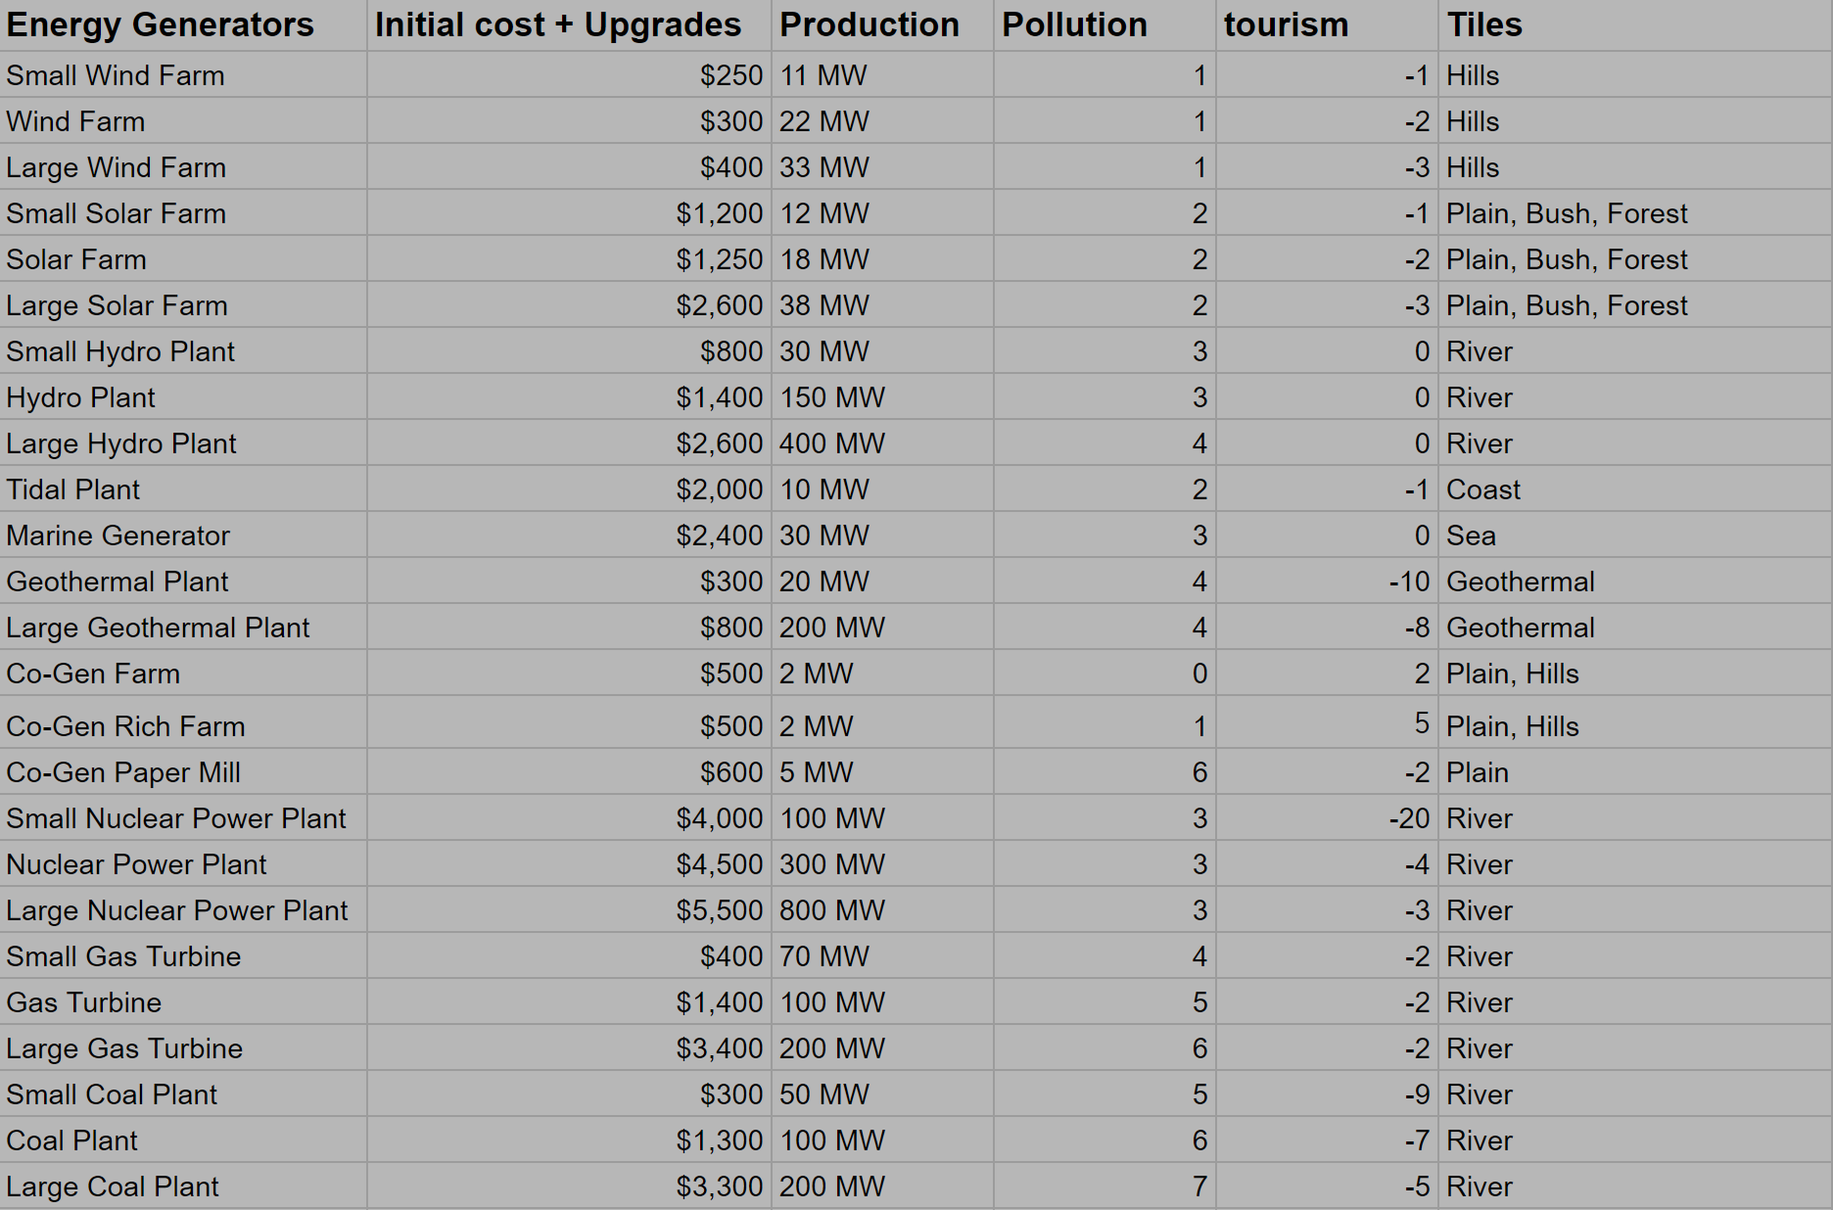
Tile cost, base and stats (pollution e.t.c)

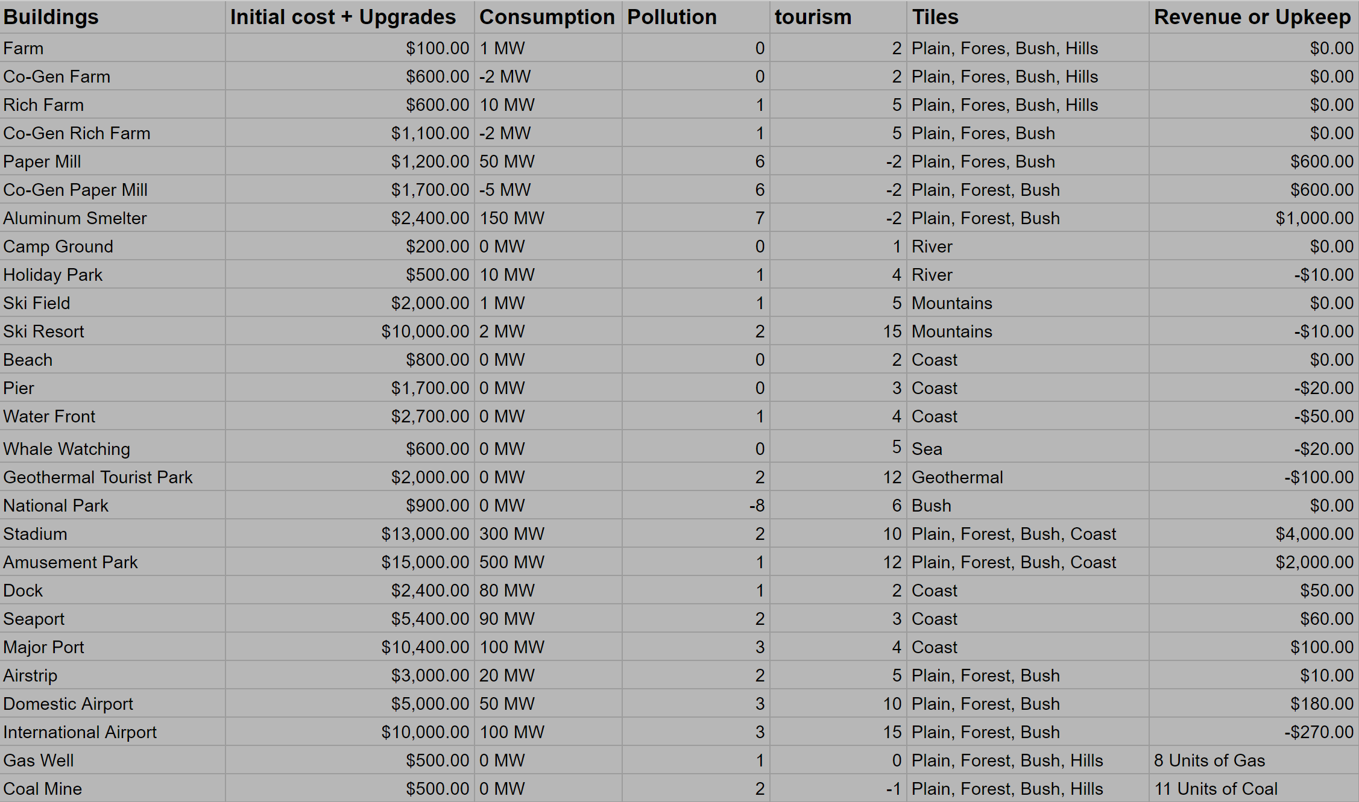

Natural Tiles

The plain tile is the most basic and is simply a flat tile that can have a large plethora of buildings built upon them. It can also have a forest planted on it.

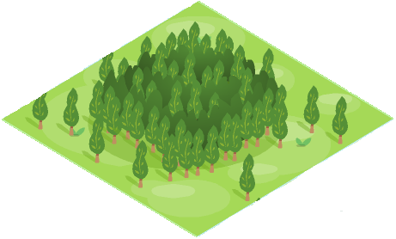
The hills can’t be built upon except farms and wind energy. They spawn in two three or four depending on the map you get.
The forest tile is the plain tile with an amount of loggable wood on top of it. The forest can be logged for a profit or left to remove pollution. If left the forest will grow increasing the amount of pollution it removes or the amount you can log. To find out the amount of pollution removed you divide the units of wood by one-hundred. Example: two-hundred thirty-seven units of wood divided by one-hundred removes two decimal three seven units of pollution.

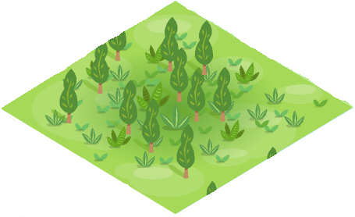
The bush tile acts the same way as the forest tile except that it is nonrenewable and that this is the only tile that a national park can be built upon.

The bush tile acts the same way as the forest tile except that it is nonrenewable and that this is the only tile that a national park can be built upon.

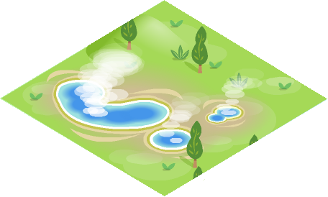
The bush tile acts the same way as the forest tile except that it is nonrenewable and that this is the only tile that a national park can be built upon.

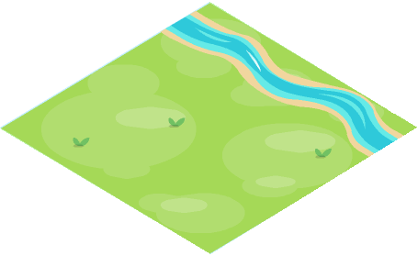
The bush tile acts the same way as the forest tile except that it is nonrenewable and that this is the only tile that a national park can be built upon.

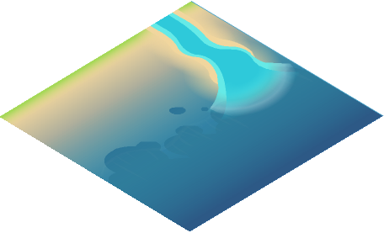
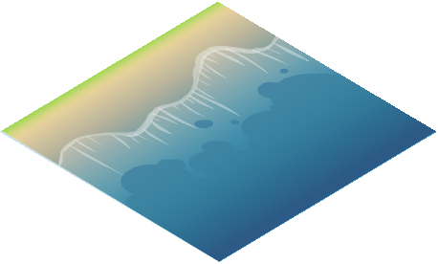
The bush tile acts the same way as the forest tile except that it is nonrenewable and that this is the only tile that a national park can be built upon.
The bush tile acts the same way as the forest tile except that it is nonrenewable and that this is the only tile that a national park can be built upon.
The ocean is a desolate tile that spawns in the bottom right side. It can have only three constructions built upon it. It can have the coal or gas drilling platforms built upon it, or the marine generator.
Acts the same as the sea tile but you also have the option of creating a whale watching spot. This increases tourism and has minor impacts on electricity and environment.

