Kam

Welcome to ElectroCity.
You will be given complete control over a small town within New Zealand. What you do with that town is up to you. You can build stuff, destroy stuff, and even leave stuff alone.
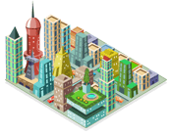
Maybe you'll build it up into a huge metropolis of grateful millions, where your name is whispered before every meal.
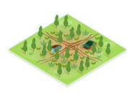
Maybe you'll bankrupt the town and turn its rivers to sludge.
Whatever happens, you may find ElectroCity easy to play but very hard to master.
ElectroCity is all about balance and planning.
You need to balance your city’s growth with its environmental impact. Your citizens need electricity and jobs, but they also love their clean green image. So you get to decide whether that forest should be made into a national park or logged and turned into an aluminum smelter.
The first thing to understand is how you’re scored at the end. Here’s an example:
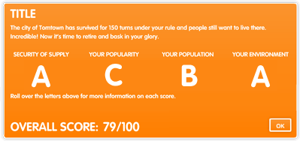
Notice that even if you do really well in one area, your overall score may not be high because you did poorly in other areas. Now you see why the game is all about balance!
There is no right or wrong way to play the game. You can experiment with different things and if your city isn’t working out, just start again.
This represents how happy your people are. Move your mouse over a face to see why it is happy or sad.
You’ll need cash to do anything. If you don’t have enough, skip through a few turns and your Local Body Rates will roll in.
Change your Local Body Rates here. Higher Local Body Rates earn you more money, but make people unhappy.
This shows if you are generating enough electricity to meet the demand. Yellow is good.
This shows how your actions are affecting the environment. Green is good.
You start the game with a natural environment and low population. All your town’s electricity is generated by one small wind farm.
Use your mouse to click on any tile and some information will pop up.
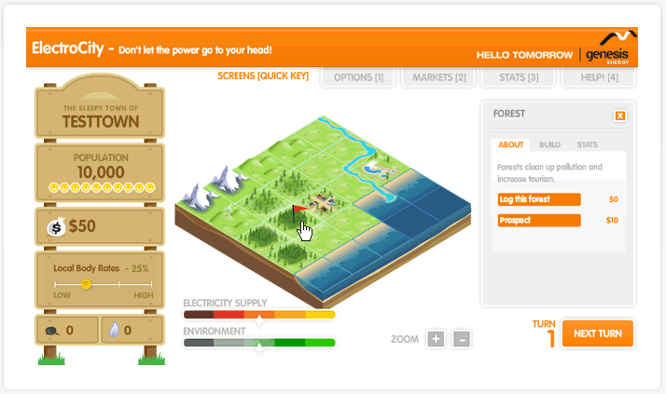
What should you do first? That is up to you, Mayor. You could...
- Save some money and do nothing
- Log a forest
- Increase Local Body Rates
- Prospect for gas or coal in a land or sea tile
- Upgrade your wind farm, ready for the future
...or a host of other things.

When you’re happy with your decisions, click the NEXT TURN button.
Now you’ll see that the orders you gave out last turn have been carried out. If your Local Body Rates are high enough, you will have made some money. If your town is nice enough, your population will increase a bit. This is easy.
But the game lasts for 150 turns, so you’ve got a long way to go yet!
Click on tiles and give more orders. If you click on the town tile in the middle you can run energy efficiency programmes, so your people use less electricity. But these programmes cost money.
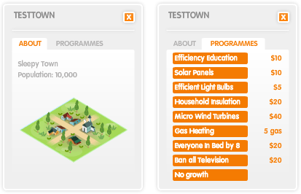
Remember, you’ll need money to build things. If you don’t have enough, skip through a few turns without building new things and your Local Body Rates will raise some cash.

Good: your town is growing. Unfortunately, so is the demand for electricity. Before long, your small wind farm will not make enough electricity to meet the demand, and you’ll need to find ways to generate more!
Your ‘Electricity Supply’ bar will start to head towards a blackout. This shows you are not generating enough electricity for your current population.
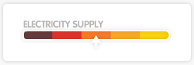
Fortunately you can save the situation. You could...
- Run an energy efficiency programme (click on your town tile)
- Upgrade your wind farm
- Build a new power plant – there are lots of options
If you do nothing, you will have to start buying electricity from other cities. This is expensive!
There are lots of ways to generate electricity, so which one is best?
That depends. They all have good and bad points. So it depends on your situation and the type of city you want to create / build.
Let’s say you prospected and found some gas under a forest.
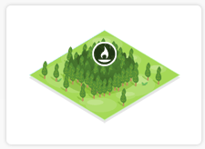
You save some money through Local Body Rates collection. When you’ve got enough, click on the forest and chose to build a gas well. Once the well is built, you will have free natural gas.
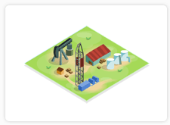
Now you might decide to build a gas plant to turn all that gas into electricity. Save some more money and choose a tile next to a river. Click on the tile and select a gas plant from the ‘Build’ menu. You will be shown all the good and bad points about gas plants and you can decide whether to start construction or not.
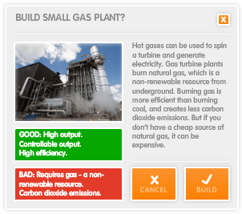

Once you start your gas plant, it will take a few turns to be completed. Once it is finished, you can click on it and you’ll see that your plant is using gas and turning it into electricity. You can even control how much electricity it makes.
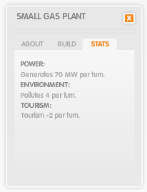
Now your ‘Electricity Supply’ bar will show that you’re producing enough electricity to meet demand.
If you don’t have a gas well, or your gas well runs out, don’t worry. You can buy gas to run your plant. It’s just cheaper if you have your own gas well.
A gas plant is just one option. You can build other power plants too, like coal plants and hydro dams. Once you’ve got enough money in the bank, solar farms and tidal plants can be built also.
It’s that easy to play! Keep your ‘Electricity Supply’ bar in the yellow zone by building power plants to meet the increasing demand.
But there are many more things to try in ElectroCity. It can be as complex or as easy as you want to make it.
There are lots of different things to build and they all have different effects on your city. Build farms to speed up your population growth, or create amusement parks to bring in tourist dollars.
You can buy and sell coal and gas on the ‘Markets’. A smart investor can make good money by watching for trends: buy when it’s cheap, sell when it’s expensive.
Be sure to check out the ‘Stats’ page, to see a snapshot of what’s been happening in your town.
- Set yourself a goal. You can aim to have...
- The biggest population
- The least environmental impact
- 100% happiness
The main thing is to have fun. Good luck Mayor!

Kam’s Game Log: First Game - Score 89/ A-

Start Game
Name: #alli Kam
Go ahead 3 turns
Build Small Hydro Plant
Go ahead 9 turns
Build Beach
Go ahead 4 turns
Upgrade Small Hydro Plant
Go ahead 2 Turns
Lower Taxes to 14%
Build Small Hydro Plant
Skip 10 Turns
Upgrade Small Hydro Plant
Skip 2 Turns
Upgrade Hydro Plant
Skip 2 Turns
Upgrade Hydro Plant
Skip 2 turns
Lower Taxes to 9%
Build Beach
Go ahead 4 turns
Build Marine Generator
Go ahead 13 turns
Build Paper Mill
Go ahead 5 turns
Build Campground
Go ahead 3 turns
Upgrade Campground
Go ahead 4 turns
Build Tourist Park
Build Campground
Go ahead 3 turns
Upgrade Campground
Go ahead 8 turns
Build Rich Farmland
Build Airstrip
Go ahead 4 turns
Upgrade Rich Farmland
Go ahead 9 turns
Upgrade Airstrip
Go ahead 2 turns
Upgrade 2 beaches
Destroy Marine Generator
Go ahead 5 turns
Upgrade 2 piers
Go ahead 6 turns
Destroy airstrip
Go ahead 4 turns
Upgrade Small Wind Farm
Go ahead 5 turns
Upgrade Wind Farm
Go ahead 3 turns
Up Taxes to 14%
Destroy Large Hydro Plant
Build Small Nuclear Plant
Go ahead 8 turns
Upgrade Small Nuclear Plant
Go ahead 2 turns
Upgrade Nuclear Plant
Go ahead 2 turns
Build Tidal Plant
Go ahead until you finish game

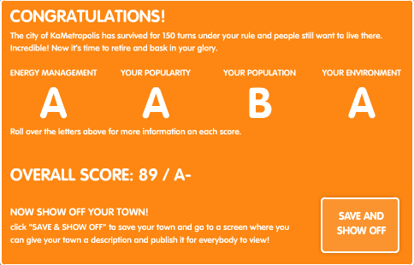
Example of Finishing Screen:

Creative Thinking/How to do Good:
People really get upset when you build things like Nuclear Plants or have too much pollution in your city. The way to counter pollution is simple. Forests, or just use “Green” energy like Hydro Plants. Me, personally, I always build two Hydro Plants and upgrade them as soon a possible in my games. If you have two “Large Hydro Plants” it will produce 800MW which is good for the early rounds. Now, you may notice that your money isn’t doing so well. This could be because you are spending too much on “Upkeeps” or not having enough population. Upkeeping things can be a killer. Say you have a beautiful Stadium or Amusement Park built and you have people rolling in by the thousands, that build could be the reason of your bankruptcy. Certain things cost extra money after you build them. Each turn it will charge you a certain amount of money.

What Works: Green energy, things to boost your population, relatively low taxes. These are simple and easy strategies. Building things that generate income (Paper mill, etc) but also having enough energy to power all your creations, watching your environmental footprint.

What Doesn’t Work: Having too many gas, nuclear or coal plants. Or having your energy, money, or environment too low. Your population doesn’t exactly have to be THAT high, but if it isn’t up you won’t generate as much tax money.

