Common Interview Mistakes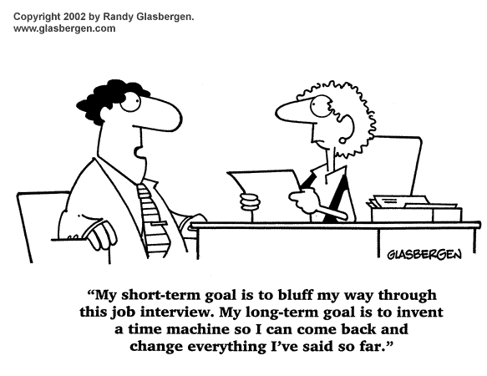
- Poor handshake: The three-second handshake that starts the interview is your first opportunity to create a great impression. But all too often an interview is blown right from the start by an ineffective handshake. Once you've delivered a poor handshake, it's nearly impossible to recover your efforts to build rapport. Here are some examples:
- The Limp Hand (or "dead fish"): Gives the impression of disinterest or weakness
- The Tips of the Fingers: Shows lack of ability to engage.
- The Arm Pump: Sincerity is questionable, much like an overly aggressive salesman.
Even if you're a seasoned professional, don't assume you have avoided these pitfalls. Your handshake may be telling more about you than you know. Ask for honest critiques from several friends who aren't afraid to tell you the truth.
- Talking too much: In my recruiting days, I abhorred over-talkative candidates. So did most of my client employers. Over-talking takes a couple of forms:
- Taking too long to answer direct questions. The impression: This candidate just can't get to the point.
- Nervous talkers. The impression: This candidate is covering up something or is outright lying.
To avoid either of these forms of over-talking, practice answering questions in a direct manner. Avoid nervous talking by preparing for your interview with role-play
- Showing up late or too early: One of the first lessons in job-search etiquette is to show up on time for interviews. Many job-seekers don't realize, however, that showing up too early often creates a poor first impression as well. Arriving more than 10 minutes early for an interview is a dead giveaway that the job seeker has too much time on his or her hands, much like the last one picked for the softball team. Don't diminish your candidate desirability by appearing desperate. Act as if your time were as valuable as the interviewer's. Always arrive on time, but never more than 10 minutes early.

- Treating the receptionist rudely: Since the first person you meet on an interview is usually a receptionist, this encounter represents the first impression you'll make. Don't mistake low rank for low input. Often that receptionist's job is to usher you into your interview. The receptionist has the power to pave your way positively or negatively before you even set eyes on the interviewer. The interviewer may also solicit the receptionist's opinion of you after you leave.

- Asking about benefits, vacation time or salary: What if a car salesman asked to see your credit report before allowing you to test drive the cars? That would be ridiculous, and you'd walk away in disgust. The effect is about the same when a job-seeker asks about benefits or other employee perks during the first interview. Wait until you've won the employer over before beginning that discussion.

- Not preparing for the interview: Nothing communicates disinterest like a candidate who hasn't bothered to do pre-interview research. On the flip side, the quickest way to a good impression is to demonstrate your interest with a few well thought out questions that reflect your knowledge of their organization.

- Verbal ticks: An ill-at-ease candidate seldom makes a good impression. The first signs of nervousness are verbal ticks. We all have them from time to time -- "umm," "like," "you know." Ignore the butterflies in your stomach and put up a front of calm confidence by avoiding verbal ticks. You can also sometimes avoid verbal ticks by pausing for a few seconds to gather your thoughts before each response.
One of the best ways to reduce or eliminate them is through role-play. Practice sharing your best success stories ahead of time, and you'll feel more relaxed during the real interview.
- Not enough/too much eye contact: Either situation can create a negative effect. Avoid eye contact and you'll seem shifty, untruthful, or disinterested; offer too much eye contact, and you'll wear the interviewer out. If you sometimes have trouble with eye-contact balance, work this issue out ahead of time in an interview practice session with a friend.

- Failure to match communication styles: It's almost impossible to make a good first impression if you can't communicate effectively with an interviewer. But you can easily change that situation by mirroring the way the interviewer treats you. For instance:
- If the interviewer seems all business, don't attempt to loosen him/her up with a joke or story. Be succinct and businesslike
- If the interviewer is personable, try discussing his/her interests. Often the items on display in the office can offer a clue.
- If asked a direct question, answer directly. Then follow up by asking if more information is needed.
Allowing the interviewer to set the tone of conversation can vastly improve your chances of making a favorable impression. You can put the interviewer at ease -- and make yourself seem more like him or her -- by mirroring his or her communication style.
- Looking sloppy: It sounds obvious, but do not go to the interview “sloppy looking”. Make sure you have had a shower, shaved, brushed your teeth, and are wearing clean clothes. Make sure clothing is appropriate for the job you are being interviewed for. Make yourself look presentable and respectful.

