- Draw and label a diagram to illustrate the property of a tangent to a circle.

- Point O is the centre of the circle. Points P and Q are points of tangency. Determine the values of x° and y. Justify your solutions.
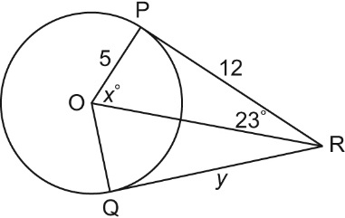

- Point O is the centre of the circle. Point P is a point of tangency. Determine the value of x to the nearest tenth. Justify your solution.
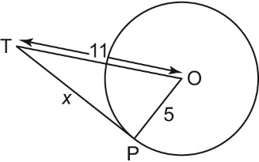

- A wheel has radius 30 cm. It rolls along the ground toward a tack that is 58 cm from the point where the wheel currently touches the ground. What is the distance, d, between the tack and the closest point on the circumference of the wheel? Give the answer to the nearest tenth of a centimetre.
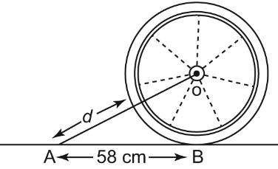

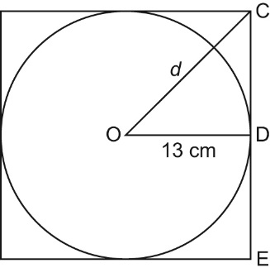
- A circular plate has radius 13 cm.
It is packed in a square cardboard frame whose 4 edges just touch the plate.
What is the distance, d, from the centre of the plate to a corner of the frame?
Give the answer to the nearest tenth of a centimetre.

- Draw and label a diagram to illustrate the relationship between a chord, its perpendicular bisector, and the centre of a circle.

- Point O is the centre of the circle. Determine the values of x° and y°.

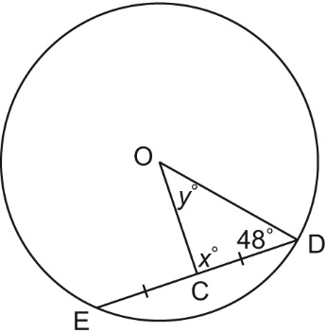

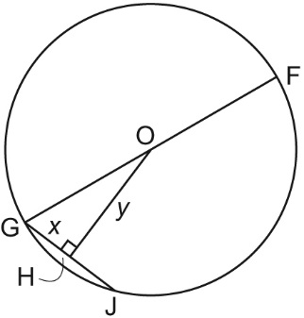
- Point O is the centre of the circle; OF = 18 cm; and GJ = 14 cm. Determine the values of x and y to the nearest tenth of a centimetre where necessary.

- A circle has diameter 70 cm. A chord in the circle is 50 cm long. How far is the chord from the centre of the circle? Give the answer to the nearest tenth of a centimetre.

10. A circle has diameter 22 cm. Two chords are drawn on opposite sides of the centre of the circle. One chord is 16 cm long and the other chord is 12 cm long.
a)Which chord is closer to the centre of the circle?
b)How much closer to the centre is this chord?
Give the answer to the nearest tenth of a centimetre.

11. Draw and label a diagram to illustrate each property.
a) an inscribed angle and a central angle subtended by the same arc
b) inscribed angles subtended by the same arc
c) an angle inscribed in a semicircle

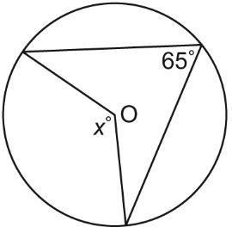
12. Point O is the centre of each circle. Determine all unknown values.
Justify your solutions.

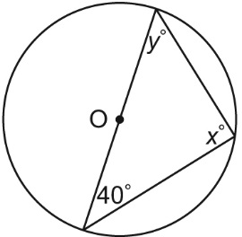

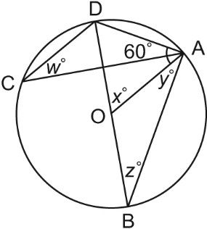
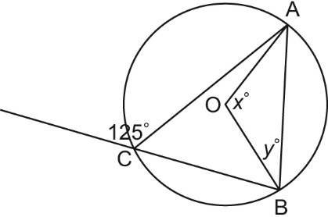

13. Use the properties of inscribed and central angles to explain why
all angles inscribed in a semicircle are right angles.

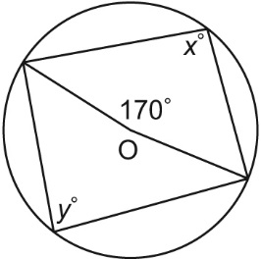
14. A student looked at the diagram below and concluded that x° = y°.
The student justified that conclusion by saying that both angles are subtended by arc AB.
What is the student’s error?
What are the values of x° and y°?

