**Chapter 5 Practice Test: Polynomials**

**Student Self-Assessment**

Please fill in the following after completing the practice test and looking at the correct solutions.

|  |  |  |  |  |  |  |
| --- | --- | --- | --- | --- | --- | --- |
| **Learning Outcomes** | | **Practice Questions** | **I get all of it** | **I get it, but made some errors** | **I get only some of it** | **I don’t get it at all** |
| B5 | Demonstrate an understanding of polynomials (limited to polynomials of degree less than or equal to 2). | #1 – 4 |  |  |  |  |
| B6 | Model, record and explain the operations of addition and subtraction of polynomial expressions, concretely, pictorially, and symbolically. | #5 – 8 |  |  |  |  |
| B7 | Model, record, and explain the operations of multiplication and division of polynomial expressions by monomials, concretely, pictorially and symbolically. | # 9 – 12 |  |  |  |  |

What do you need to work on? What is your plan to ensure you will be successful come test day?

____________________________________________________________________________________________________________

____________________________________________________________________________________________________________

____________________________________________________________________________________________________________

____________________________________________________________________________________________________________

____________________________________________________________________________________________________________

____________________________________________________________________________________________________________

____________________________________________________________________________________________________________

1. Model the following polynomial expressions using **algebra tiles**.
2. $-3a^{2}- 2a+1$ b) $5m-3$
3. Write the **polynomial** for the given model.



a) b)

1. Complete the following table:

|  |  |  |  |  |  |  |
| --- | --- | --- | --- | --- | --- | --- |
| Polynomial | Coefficient(s) | Constant | Variable(s) | Degree | Number of Terms | Type of Polynomial |
| 4 – 11*w* |  |  |  |  |  |  |
| –2 + *y*2 + 5*xy* |  |  |  |  |  |  |

1. Identify the **equivalent polynomials** from the list below. Please show all work to justify your answer.
$1+3x- x^{2}$

$1+ 3x^{2}- x^{2}+ 2x-2x^{2}+ x-2$

$3x- x^{2}+ 1$

$6+6x-6x^{2}- 4x-5+2x^{2}+ x^{2}- 4$

$-3x^{2}+ 2x-3$

$3x-1$

2. Add or subtract the following polynomials.
$\left(6a^{2}+ 2a-2\right)+ \left(-7a^{2}+ 4a+11\right)$

$\left(-14+3p^{2}+ 2p\right)- \left(-5p+10\right)$

$\left(-5q^{2}+3p-2q+p^{2}\right)-\left(4p+q+p^{2}\right)$

3. Determine the **perimeter**. Show your work clearly.

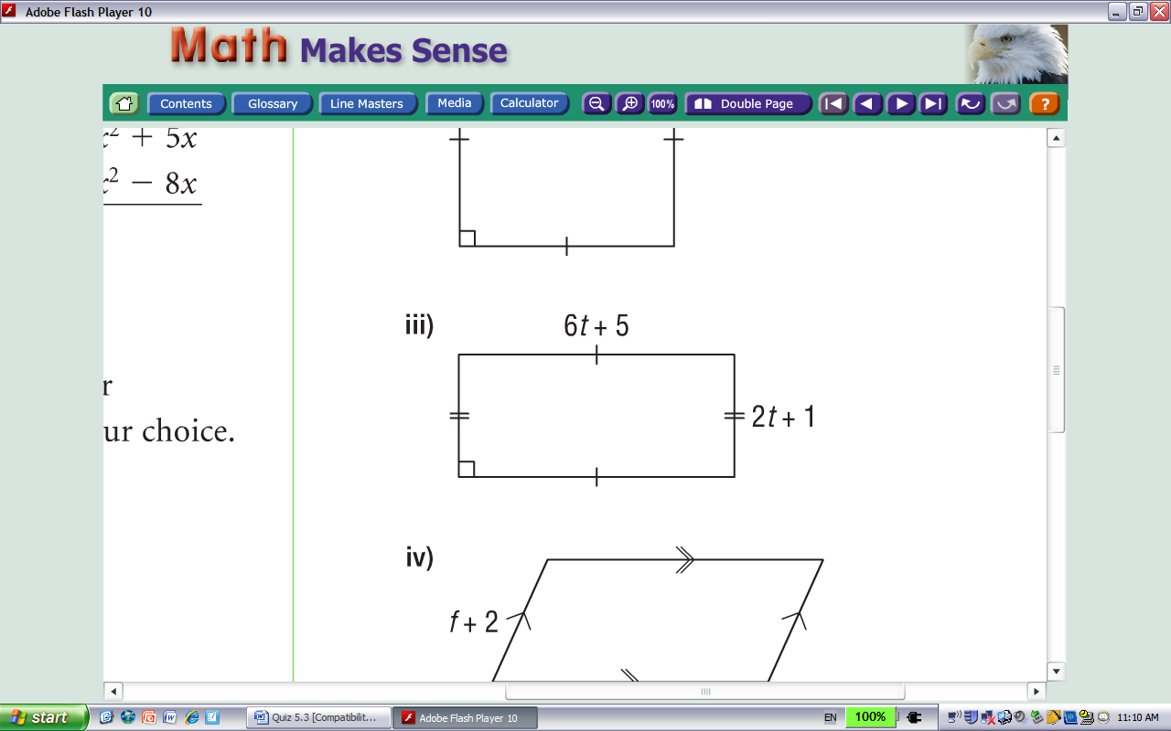

1. a) What polynomial must be **added to $5x^{2}+ 3x-2$** to get $7x^{2}-2x+6$?
2. What polynomial must be **added to $-2x^{2}+4x-1$** to get a sum of **zero**?
3. What polynomial must be **subtracted from $5x^{2}+ 3x-2$** to get $7x^{2}+ 2x-5$? Show your work and/or reasoning.
4. Determine each product.
5. $2\left(-3p^{2}- 2p+1\right)$ b) $-5t\left(t-3\right)$ c) $\left(-4y+1\right)\left(7y\right)$
6. Determine each quotient.

a) $\frac{-6q^{2 }- 10}{2}$ b) $24j ÷ \left(-6j\right)$ c) $\frac{14{xy}^{2} - 21y}{-7y}$

1. Write a simplified polynomial for the **area** of this shape. Show your work.

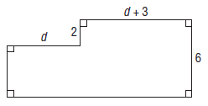

1. a) Find the simplified polynomial that represents the **area of the shaded region**. Show

your work.

4*x* – 1

3*x*



3*x*

2*x* + 1

1. Find the shaded area if $x=3$ cm.

**Answers to Chapter 5 Practice Test**

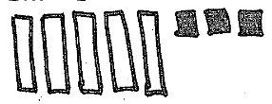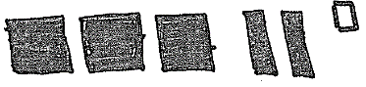

1. a) b)
2. a) $-x^{2}+12$ b) $-4x$

|  |  |  |  |  |  |  |
| --- | --- | --- | --- | --- | --- | --- |
| Polynomial | Coefficient(s) | Constant | Variable(s) | Degree | Number of Terms | Type of Polynomial |
| 4 – 11*w* | –11 | 4 | *w* | 1 | 2 | binomial |
| –2 + *y*2 + 5*xy* | 1 and 5 | –2 | *x* and *y* | 2 | 3 | trinomial |

1. I and III, II and VI, IV and V
2. a) $-a^{2}+6a+9$ b) $3p^{2}+7p-24$ c) $-5q^{2}-p-3q$
$16t+12$

3. a) $2x^{2}-5x+8$ b) $2x^{2}-4x+1$
$-2x^{2}+x+3$

4. a) $-6p^{2}-4p+2$ b) $-5t^{2}+15t$ c) $-28y^{2}+7y$
5. a) $-3q^{2}-5$ b) $-4$ c) $-2xy+3$
$10d+18$

7. a) b) 36 cm2