Board Game Assignment and Rubric

Group members’ names: _______________________________________________________

Assignment:

You are a board game manufacturer, and you have been assigned the task of creating an original board game that fosters positive relationships or creates new positive relationships. Consider what you know about relationships and what is involved in a healthy relationship. What kind of game will help relationships grow stronger? Be creative!!!!!

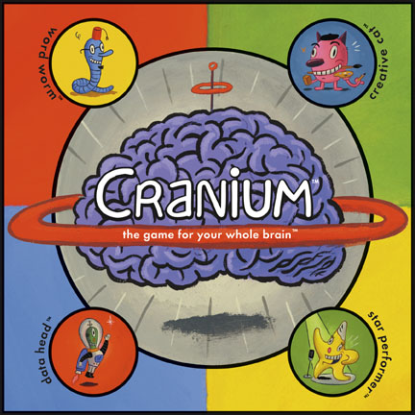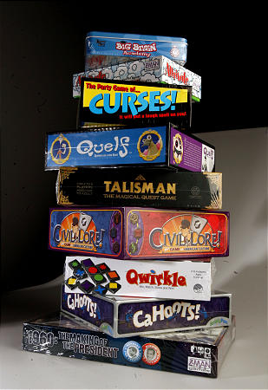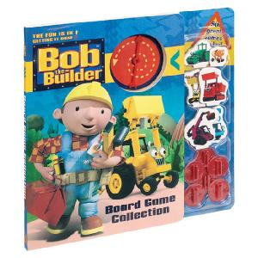
Requirements:

  - Using appropriate resources, create a final game board and any necessary game pieces. Make it neat, colorful, interesting, and creative.

10 Marks  Everything is neatly created and directions were followed completely. | 8 Marks  Game board and pieces are excellent but some parts are a little sloppy. | 6 Marks  Game board and pieces are complete but 1 or 2 elements are missing and it could be neater. | 4 Marks  Most of the directions were ignored and the board is sloppy. | 2 Marks  There is a game board but it is not coloured and no extra efforts were made at creativity.

  - Write directions/rules for your game that would make it perfectly clear how to play the game. Type the directions/rules.

10 Marks  Directions make it perfectly clear how to play the game. They are neatly written with minimal grammatical errors. | 8 Marks  Directions have 2-3 minor grammatical errors. They are somewhat unclear or 1 step is missing. | 6 Marks  There are more than 3 errors. Directions are unclear and 2-3 steps could be added to clarify. | 4 Marks  Errors in grammar interfere with understanding of the directions. Much revision is needed. | 2 Marks  Complete revision needed. Many steps are missing or incomplete and it is very difficult to understand how to play the game.

  - Content and difficulty

10 Marks  Questions and rules of play are of an appropriate level—not too difficult and not too easy. | 8 Marks  Rules of play are age appropriate but some questions are too easy or too difficult. | 6 Marks  Game is a bit too simple for the grade level and some questions are too easy. | 4 Marks  Game is very simple and most questions are too easily answered. | 2 Marks  Game is not appropriate for the grade level and questions are too easy or too difficult.

Total: /30 Marks

