Assessment Focus Questions Name: _________________________
Right Rectangular Prism and Right Triangular Prism
- Sketch 3 different nets for this object.

3cm
3 cm
3 cm

- Calculate the surface area and volume of each prism.
2 cm
2 cm

10 cm

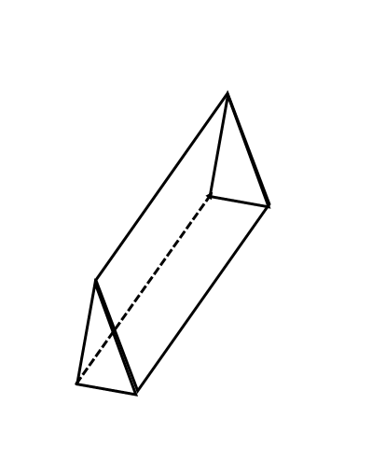
12.0 cm
10.0 cm
10.0 cm
8.7 cm

