Unit 8: Shape and Space- Transformations and Tessellations

Name: _____________________ Date: ________________________

1. Use this design.
Match each transformation to a transformation image.
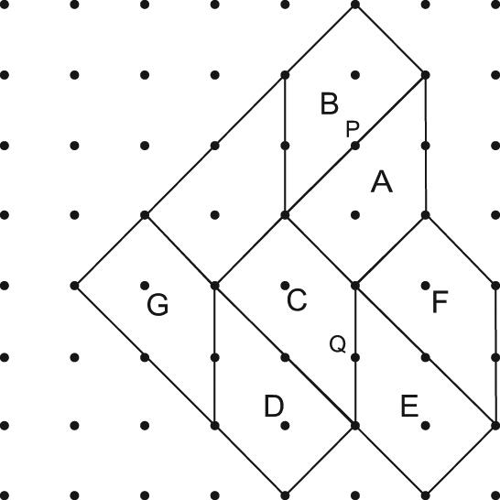

a) Rotate Shape A 180° about point P.
b) Translate Shape C 2 units left.
c) Rotate Shape D 180° about point Q.
d) Translate Shape G 4 units right.

2. Copy each shape on grid paper.
Show one way each shape can be used to tessellate.
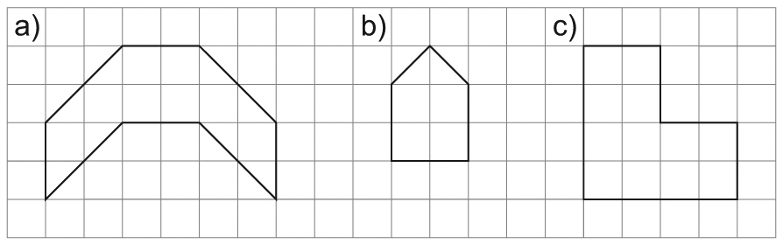

3. Here are three patterns.
Describe the transformations that can be used to create each pattern.
Start with the shaded shape.
a)
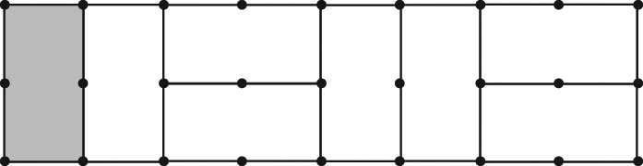

b)
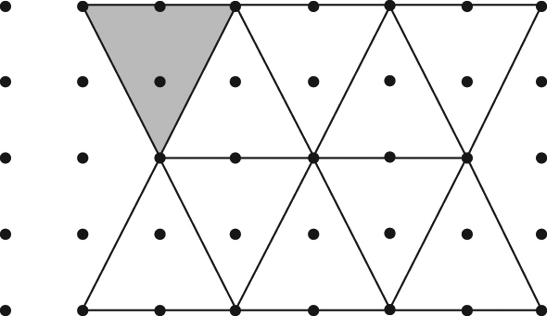

c)
