Collections, part 1
Make a collection of pieces, using all three kinds, and write down its name. Settle on a convention for writing collections which shows that all the pieces are added together in one collection. Abbreviations might help. You could call this collection:
2BS + 3R + 5 (for two big squares, three rectangles and five nameless ones)
or 2R² + 3R + 5 (for two rectangle squares, three rectangles, and five nameless ones)
or 2x² + 3x + 5 (for two X², three X, and five ones)
Here you want to try to get the names sorted out, so that groups can describe their collections. Have the students draw their collections, and write the names of the collections with symbols.

Collections, part 2
Combine the collection you made with a collection another group member made. How would you name the resulting collection? How would you draw or write the action of combining them?
Now make a collection and take some pieces out of it. How would you name the resulting collection? How would you draw or write the action of taking out pieces from a collection?
This is introducing the idea of adding and subtracting polynomials. Not much attention needs to be paid to this right now. All we are doing is agreeing on some more notational conventions:
(2R² + 3R + 5) + (R² + 2R + 6) = (3R² + 5R + 11) means:
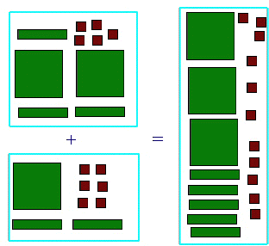
and
(2R² + 3R + 5) - (R² + 2R + 3) = (R² + R + 2) means:
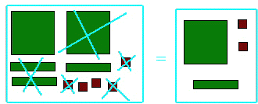
where crossing out the picture of a tile denotes removing it from the collection.
Again, have students perform the action on the tiles, and then draw the actions, and then write the symbols for the actions. If some of your lazier students want to stop drawing everything and just write symbols, that might be OK, but don't let them get the idea that drawing pictures and moving tiles is the "bad" way to do things.

Making rectangles.
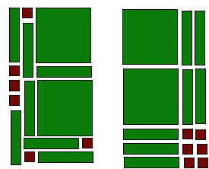
Make a collection with two big squares, seven rectangles, and six nameless ones. How would you name that collection? Now arrange the collection so it makes a rectangle.
Both of these are rectangles made with the same pieces. I like the one on the right better. Why not introduce some aesthetic rules of Algebra tile rectangles? My first rule would be:
- Big squares can't touch little squares.
My second rule (which I am more lenient about) is:
- Little squares must all be together.

Measuring
Use rectangles and nameless ones to "measure" the length and width of your rectangles. For example:
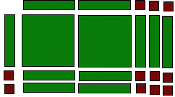
the length and width of this rectangle are 2R+3 and R+2. It is sometimes confusing to have the measuring tiles so close to the rectangle. To clarify we can use "crossed lines" to separate them. (The X in the corner is because they are "crossed")
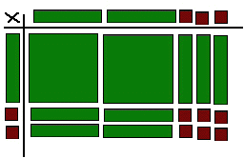
Spend some time on making rectangles, drawing them, measuring them, and writing down the collections and their measurements. For example, I could write (2R²+7R+6) = (R+2)x(2R+3) for the rectangle I made above.

