9SS1 V3 Shape & Space – Circle Properties

Part I:
- Label each line segment using proper terminology.
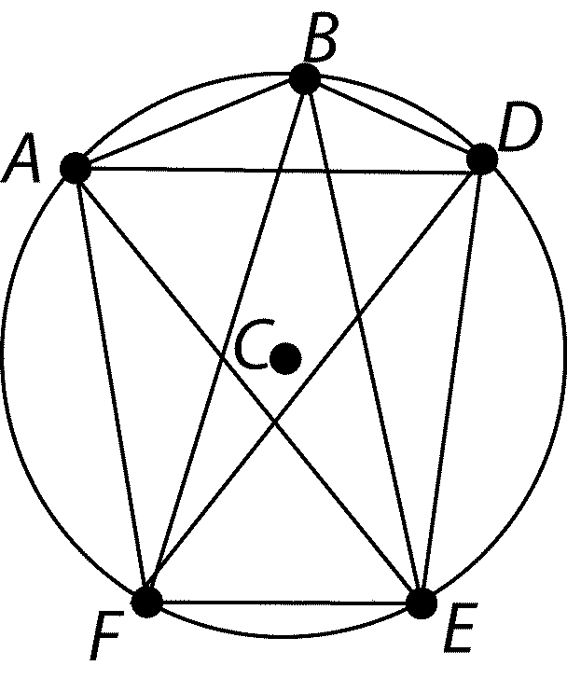
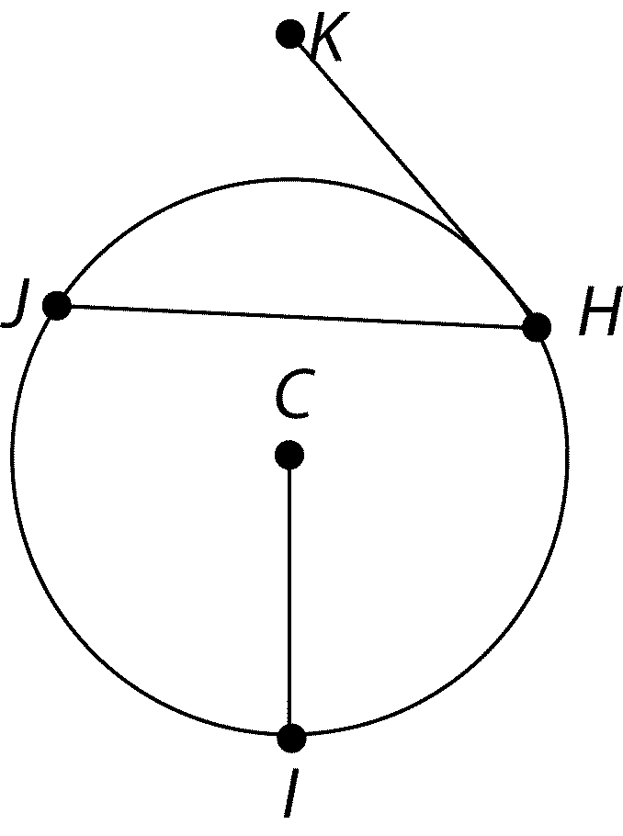
- List two different pairs of angles that are congruent.

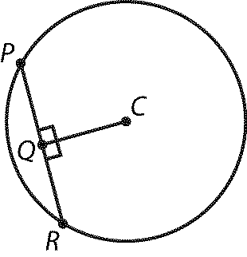
- In the circle shown, PR = 12 cm. What is the length of QR?

Part II:
- A metal disc is to be cut from a square sheet with side length of 50 cm. How far from a corner of the sheet is the center of this disc?

50 cm

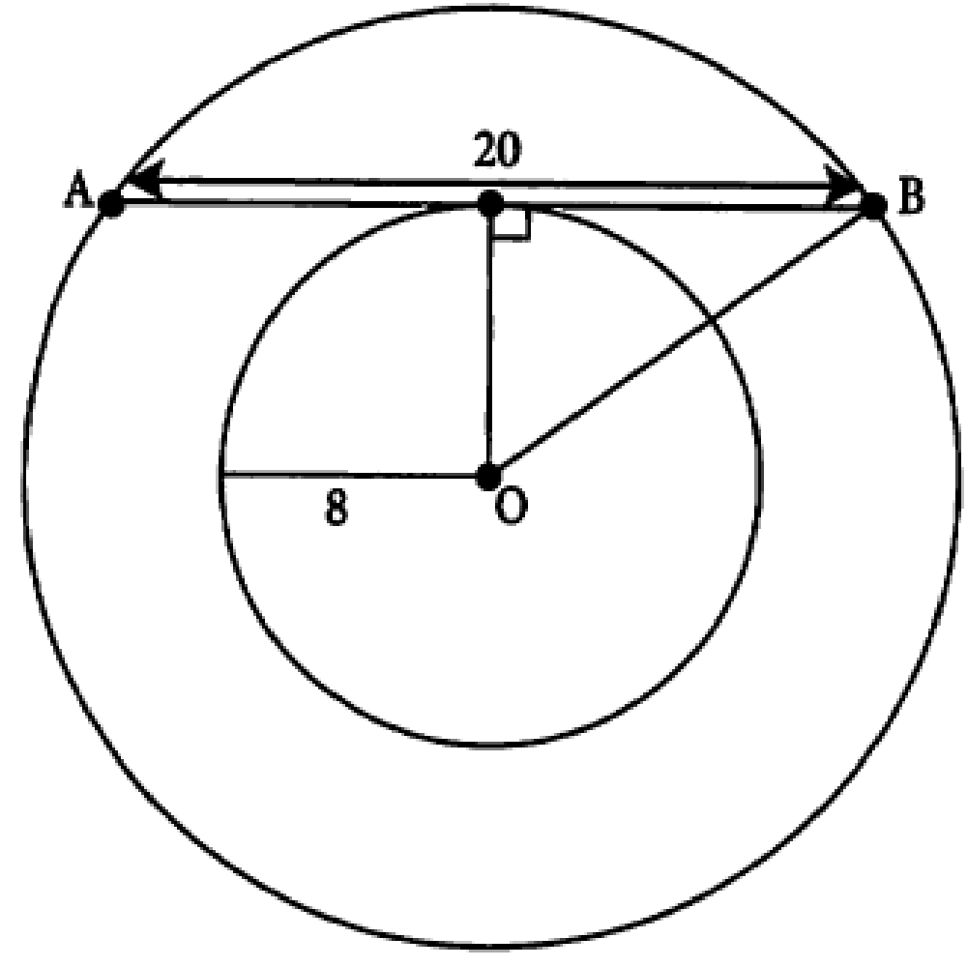
- A pool with a radius of 8 ft is surrounded by a wooden deck as shown. If the distance from A to B is 20 ft, find the width of the deck surrounding the pool.

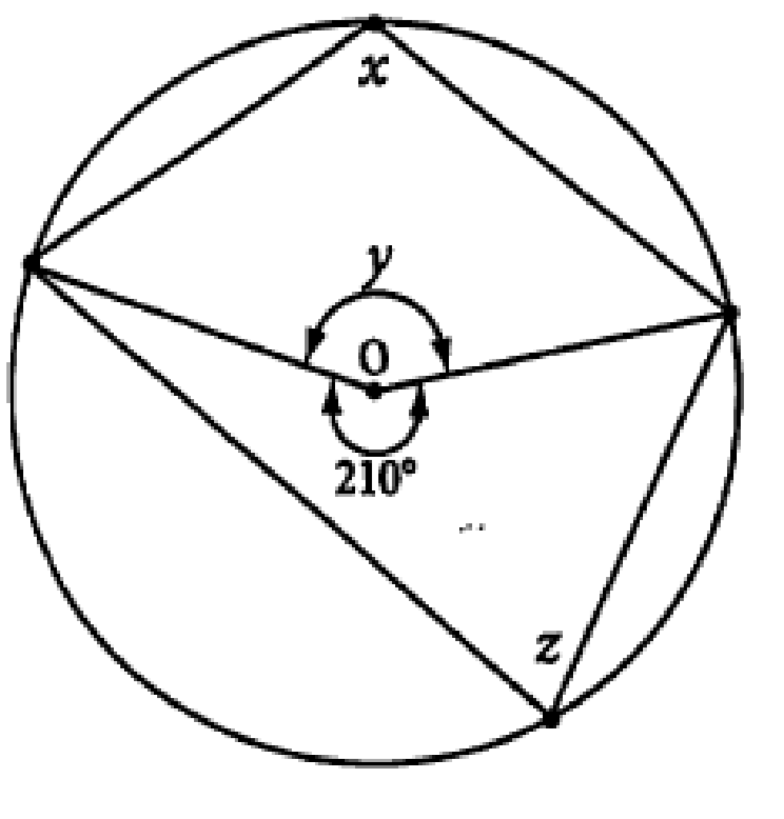
- Determine the measure of angle
  - x
  - y
  - z

Part III:
- If JG is a tangent to the circle, what is the value of x and the measure of $∠JGH$.

J
H

G

