**9SS1 V2 Shape and Space – Circle Properties**

**Part I:**

1. 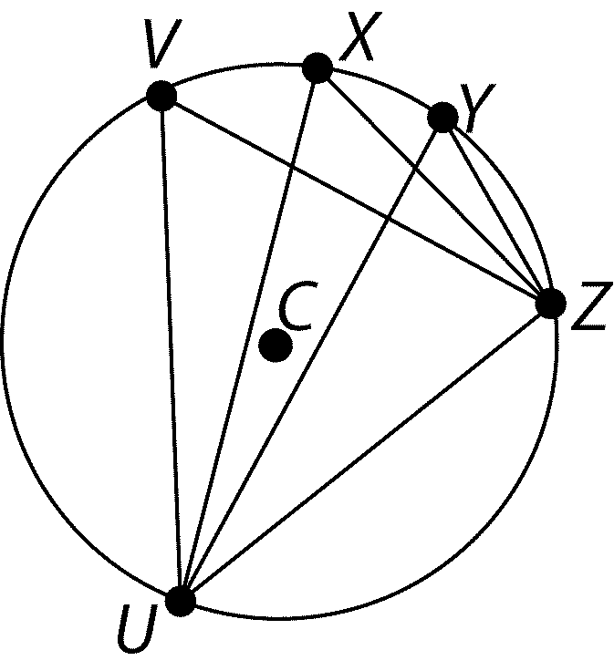If *M* = 47, determine the measure of the central angle.
2. 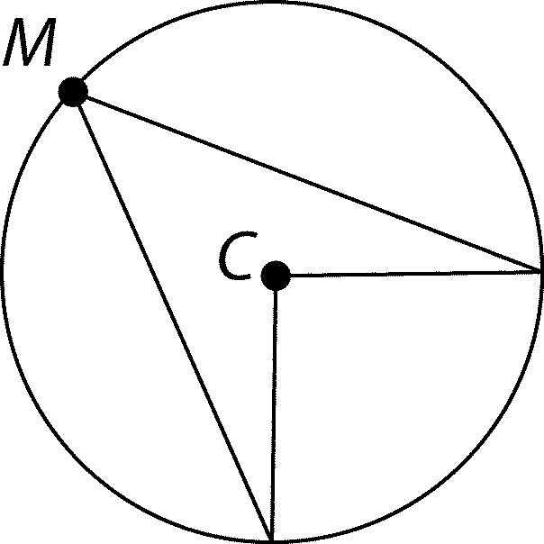List three angles have the same measurement?

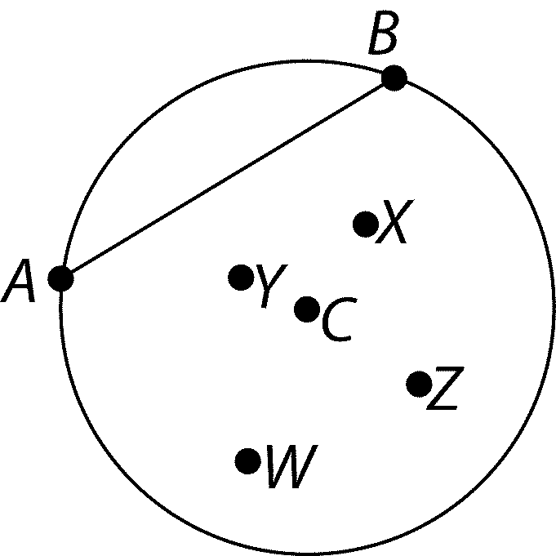

1. The perpendicular bisector of *AB* must pass through which point(s)?
2. Correct each of the statements below about the circle in the diagram.
3. 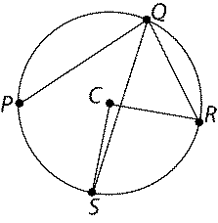SCR is smaller than SQR
4. PQR is subtended by minor arc PS
5. CR is a chord

**Part II:**

1. Water is flowing through a cylindrical pipe with a radius of 22 cm. The water has a depth of 8 cm. What is the width of the surface of the water?
2. Point O is the centre of the circle. Determine the values of *x*°, *y*°, and *z*°.

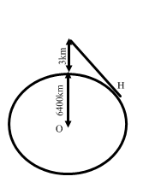

S

1. Skydiver, S, jumps from a plane at an altitude of 3 km.

The radius of the earth is 6400 km. How far is the landing point, H, from the skydiver when she leaves the plane?

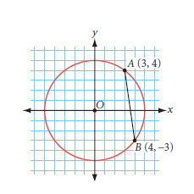

**Part III:**

1. Write the equation of the perpendicular bisector of line AB.

Explain how you know it passes through the center of the circle.