**9SS1 V1 Shape and Space – Circle Properties**

**Part I:**

1. Define each of the following terms and provide a diagram.
   1. Chord
   2. Central Angle
   3. Inscribed Angle
   4. Tangent
2. If *C* = 96, determine the measure of *M*.

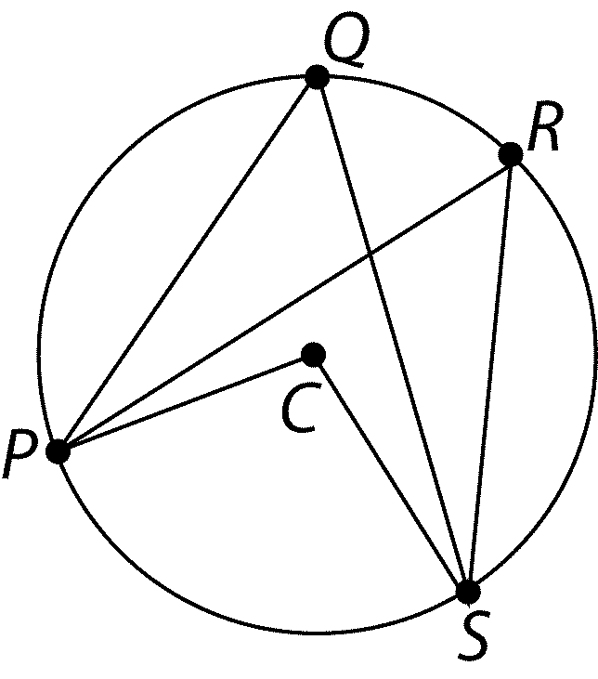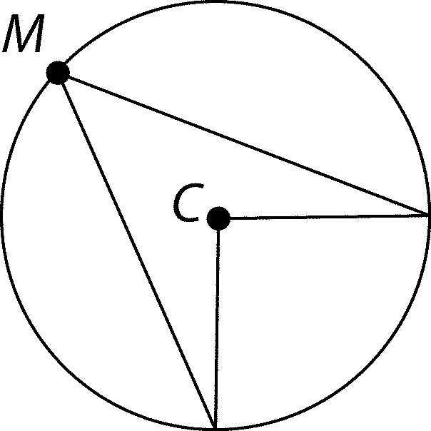

1. What is the relation between *PQS* and *PRS*?

**Part II:**

1. A circle has a diameter of 25 cm. How far from the center of this circle is a chord 16 cm long?
2. If *XY* = 7 cm and *CX* = 4 cm, calculate *CY.*

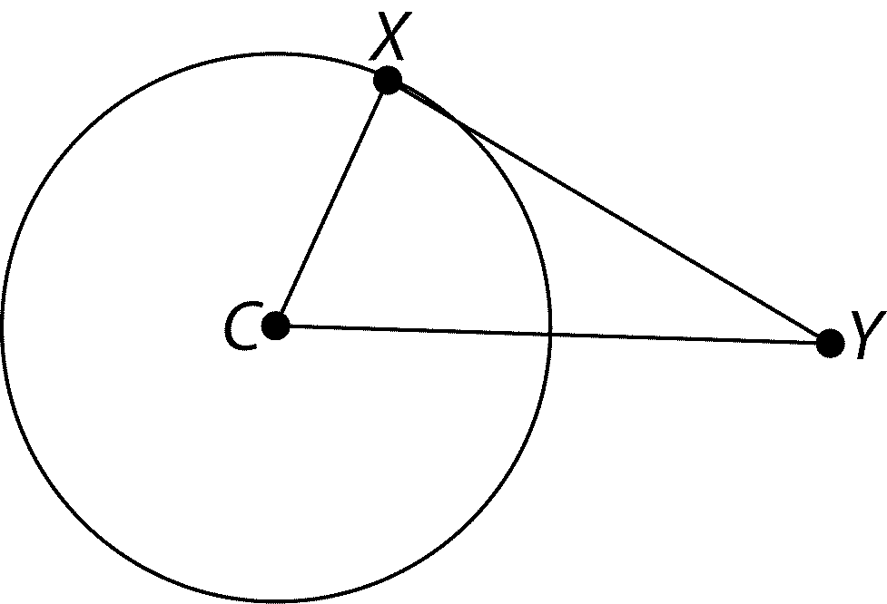

1. Determine the measure of angle
   1. *x*
   2. *y*
   3. *z*

**Part III:**

1. 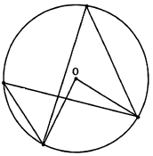Determine the value of *a* and *b*.

$$5a+12$$

$$3(a+6)$$

$$\frac{b}{3}+4$$