5.5 Practice – Multiplying a Polynomial by a Monomial
1. Multiply.
a) 2(3b) b) –2(6h) c) –4(–2b²)

d) –2(2x² + y²) e) –2(–xy² + 3xy + 4x²y) f) –3(–2fg )

2. Determine each product.
a) 4(3a + 2) b) (d² + 2d)(–3) c) 2(4c² – 2c + 3)

d) (–2n² + n – 1)(6) e) –3(–5m² + 6m + 7)

3. Here is a student’s solution for a multiplication question.
(–5k² – k – 3)(–2)
= –2(5k²) – 2(k) –2(3)
= –10k² – 2k – 6
a) Explain why the student’s solution is incorrect.

b) What is the correct answer? Show your work.

4. Find the area of each rectangle.

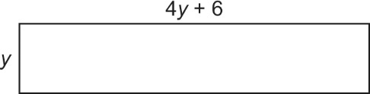
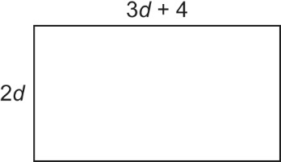
a) b)

5. Multiply.
a) v(3v + 1) b) 3c(5c + 2) c) (8 + 4y – 2x)(6y)

d) 5p(–5 – 2pq) e) (7k – 3)(–m) f) (–1 – 10r + r²)( –r)

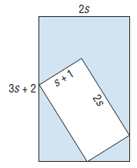
6. a) Write a simplified polynomial to represent the shaded area.

b) Determine the shaded area when s = 3 cm.

7. Write a simplified polynomial for the area of this shape.
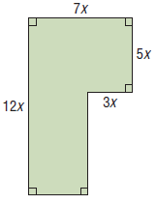

5.5 Practice – Answers
1. a) 6b b) –12h c) 8b² d) –4x² – 2y² e) 2xy² – 6xy – 8x²y f) 6fg
2. a) 12a + 8 b) –3d² – 6d c) 8c² – 4c + 6 d) –12n² + 6n – 6 e) 15m² – 18m – 21
3. a) The negative signs in the first polynomial were forgotten when (–2) was distributed.
b) 10k² + 2k + 6
4. a) 6d² + 8d b) 4y² + 6y
5. a) 3v² + v b) 15c² + 6c c) 48y + 24y² – 12xy d) –25p – 10p²q e) –7km + 3m f) r + 10r² – r³
6. a) 4s² + 2s b) 42 cm²
7. 63x²

