5.3 Practice – Adding Polynomials
1. Use algebra tiles to model each sum. Sketch your tile model. Record your answer symbolically.

a) (– 4h + 1) + (6h + 3) b) (2a² + a) + (–5a² + 3a)

c) (3y² – 2y + 5) + (–y² + 6y + 3) d) (3 – 2y + y²) + (–1 + y – 3y²)

2. Add these polynomials. Use algebra tiles if it helps.

a) (x – 5) + (2x + 2) b) (b² + 3b) + (b² – 3b)

c) (y² + 6y) + (–7y² + 2y) d) (5n² + 5) + (–1 – 3n²)

3. Add these polynomials. Use algebra tiles if it helps.
a) (–7x + 5) b) (4x² – 3)
+ (2x – 8) + (–8x² – 1)

c) (x² – 4x + 3) d) (3x² – 4x + 1)
+ (–x² – 2x – 3) + (–2x² + 4x + 1)

4. Add.
a) (y² + 6y – 5) + (–7y² + 2y – 2) b) (–2n + 2n² + 2) + (–1 – 7n² + n)

c) (3m² + m) + (–10m² – m – 2) d) (–3d² + 2) + (–2 – 7d² + d)

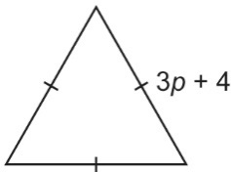
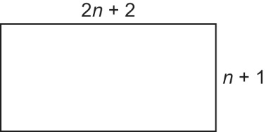
5. For each shape below, write the perimeter as a sum of polynomials and in simplest form.
a) b)

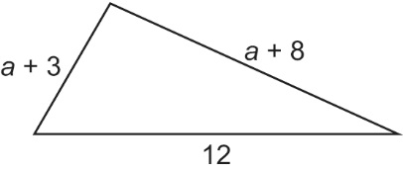
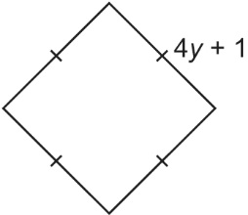
c) d)

6. The sum of two polynomials is 4r + 5 – 3r². One polynomial is –8 – 2r² + 2r; what is the other polynomial? Explain how you found your answer.

5.3 Practice – Answers

1. a) 2h + 4 b) –3a² + 4a c) 2y² + 4y + 8 d) – 2y² – y + 2
2. a) 3x – 3 b) 2b² c) –6y² + 8y d) 2n² + 4
3. a) –5x – 3 b) –4x² – 4 c) –6x d) x² + 2
4. a) –6y² + 8y – 7 b) – 5n² –n + 1 c) –7m² – 2 d) –10d² + d
5. a) 6n + 6 b) 9p + 12 c) 16y + 4 d) 2a + 23
6. – r² + 2r +13

