4.5 Practice – Using Graphs to Estimate Values
1. The graph on the right represents a linear relation.

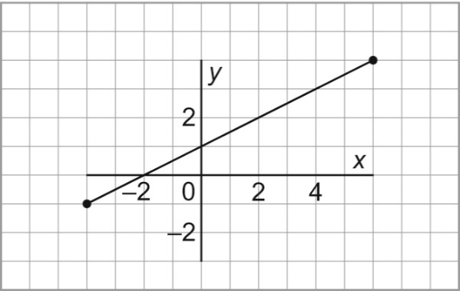
- Determine the value of x for each value of y.

i) y = 1

ii) y = 3

iii) y = 0

b) Determine the value of y for each value of x.

i) x = 2

ii) x = 8

iii) x = –6

2. The graph on the right represents a linear relation.

- Determine the value of x for each value of y.
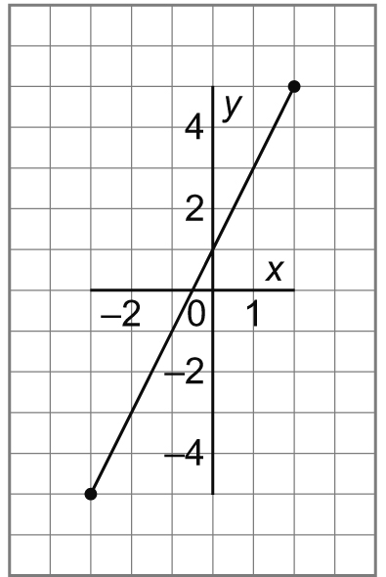
i) y = 3

ii) y = –2

iii) y = 7

- Determine the value of y for each value of x.

i) x = 0

ii) x = –2

iii) x = –4

3. This graph represents a linear relation.

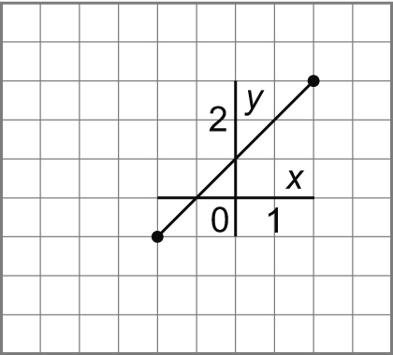
- Determine the value of x for each value of y.

i) y = 2

ii) y = 0

iii) y = 5

- Determine the value of y for each value of x.

i) x = 0

ii) x = 3

iii) x = –5

4. The graph shows how the cost of a long distance call changes with the time for the call.

- Estimate the cost of a 7-min call. Is this interpolation or extrapolation? Explain.

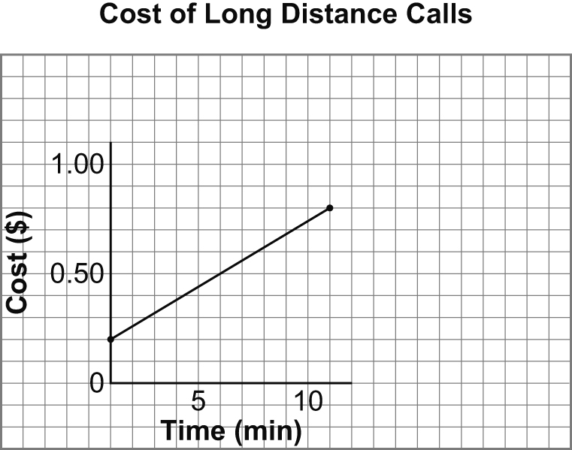
- The cost of a call was $1.00. Estimate the time for the call.

- The cost of a call was $1.50. Estimate the time for the call. Is this interpolation or extrapolation?

4.5 Practice – Answers

1. a) i) x = 0 ii) x = 4 iii) x = –2 b) i) y = 2 ii) y = 5 iii) y = –2
2. a) i) x = 1 ii) x = –1.5 iii) x = 3 b) i) y = 1 ii) y = –3 iii) y = –7
3. a) i) x = 1 ii) x = –1 iii) x = 4 b) i) y = 1 ii) y = 4 iii) y = –4
4. a) Approx. $0.56. Interpolation since reading a data point that lies between the plotted points.
b) Approx. 13 min
c) Approx. 22 min. Extrapolation since reading a data point beyond the plotted points.

