4.5 – Using Graphs to Estimate Values

Linear graphs can be useful to make quick estimations for data. When we estimate values that are between two data points on the graph, it is called _________________________________________________. When we estimate values that go beyond the graph, assuming the relation continues to be linear, it is called ____________________________________________________.

Ex. 1: The graph below shows how the speed in metres per second relates to a speed in kilometres per hour.

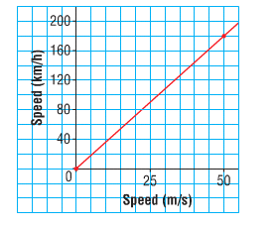

- Estimate the speed, in metres per second, of:

- A car that is travelling at 70 km/h

- A train that is travelling at 140 km/h

- Estimate the speed, in kilometres per hour, of:

- A racing car that is travelling at 60 m/s

- A bicycle that is travelling at 8 m/s

Ex. 2: Use this graph of a linear relation.

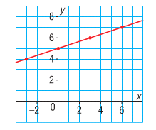

- Determine the value of $y$ when $x=5$

- Determine the value of $x$ when $y=3$

