4.4 Practice – Matching Equations and Graphs
*Note: You must show how you made your decisions to prove you didn't just copy the answers!
1. Match each equation with a graph on the grid. Show your work or thought process.
a) y = 2x – 1 b) y = –x + 4 c) y = 3x – 3
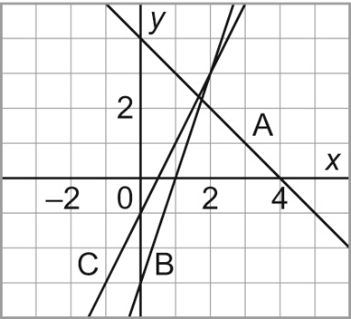

2. Match each equation with a graph on the grid. Show your work or thought process.
a) x = 1 b) y = – 1 c) x = 2.5
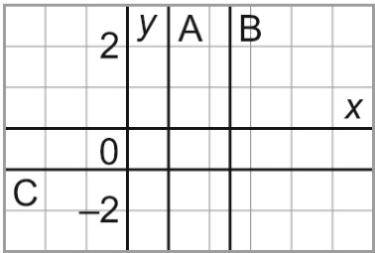

3. Match each equation with a graph on the grid. Show your work or thought process.
a) x + y = 5 b) x – y = 5 c) x + y = –5
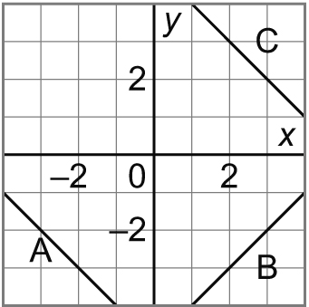

4. Which equation describes this graph? Show your work or thought process.
a) y = x + 2 b) y = –x + 2 c) y = x – 2

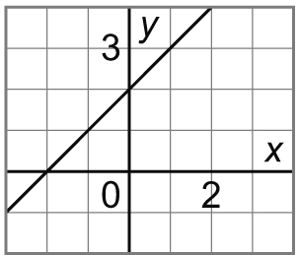

5. Which equation describes this graph? Show your work or thought process.
a) x – y = 4 b) x – 4y = 4 c) 4x – y = 1

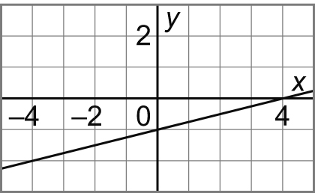

4.4 Practice – Answers

1. a) Graph C b) Graph A c) Graph B
2. a) Graph A b) Graph C c) Graph B
3. a) Graph C b) Graph B c) Graph A
4. y = x + 2
5. x – 4y = 4

