4.4 – Matching Equations and Graphs
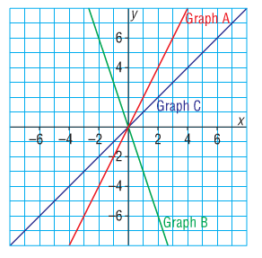
Ex. 1: Match each graph on the grid with its equation:

$y=x$ $y=2x$ $y=-3x$

Method 1: Choose an x-value and substitute it into
each equation to determine the corresponding
y-value. This will give you a coordinate. Look for the
graph that goes through this coordinate.

Method 2: Find the y-intercept and the slope from the equation and see which graph has these properties.

Ex. 2: Match each of these equations with either graph A, B, or C.

$y=3x+3$ $x+y=3$ $y=3x-3$
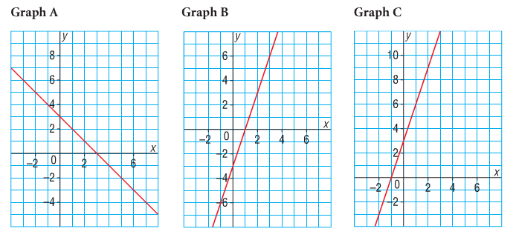

Method 1: Choose an x-value and substitute it into each equation to determine the corresponding
y-value. This will give you a coordinate. Look for the graph that goes through this coordinate.

Method 2: Find the y-intercept and the slope from the equation and see which graph has these properties.

