**4.2 – Linear Relations**

Recall that we have a **linear relation** if a constant change in one variable produces a constant change in the other.

Ex. 1: Are the following relations linear?

|  |  |
| --- | --- |
| $$x$$ | $$y$$ |
| 1 | 4 |
| 2 | 13 |
| 3 | 22 |
| 4 | 31 |

|  |  |
| --- | --- |
|  |  |
| 1 | 2 |
| 2 | 4 |
| 3 | 8 |
| 4 | 14 |

|  |  |
| --- | --- |
|  |  |
| 9 | -8 |
| 6 | 2 |
| 3 | 12 |
| 0 | 22 |

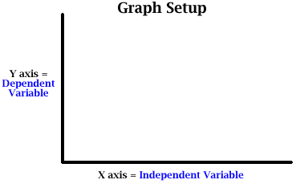When graphing data, we always plot the **independent variable** on the horizontal ($x$) axis and the **dependent variable** on the vertical ($y$) axis. We can identify which is which by asking which variable depends on the other.

Eg. Distance driven and time

Diver’s depth and water pressure

Before joining the data points on a graph, ask yourself whether it is possible to have decimal or fraction values for the variables. If yes, we say the data is **continuous**. If not, it is **discrete**. In a table of values, it is best to put the independent variable in the left column, and the dependent in the right.

Ex. 2: A relation has the equation $y=1-2x$

1. Create a table of values and graph the relation. Does it make sense to join the points on the graph?
2. What patterns are in the graph? Is the relation linear?

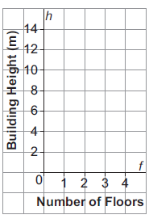Ex. 3: A one-story building is 5 m high. Each additional story adds another 3 m.

1. Create a table of values and graph the relation. Does it make sense to join the points?
2. Write an equation to relate the height of the building, *h*, to the number of stories, *s*.