1. 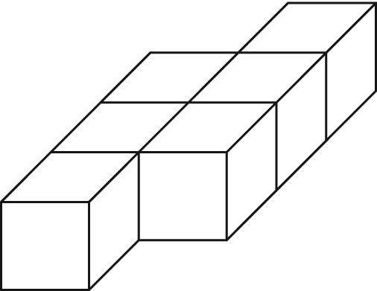The object at the right is constructed using  
   linking cubes. Each face of a cube has an area   
   of 1 unit2.

**a)** Describe or show on the diagram where   
there are overlapping faces.

**b)** Determine the surface area of the composite object.

1. 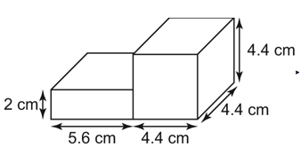Determine the surface area of the  
   composite object at the right.

1. 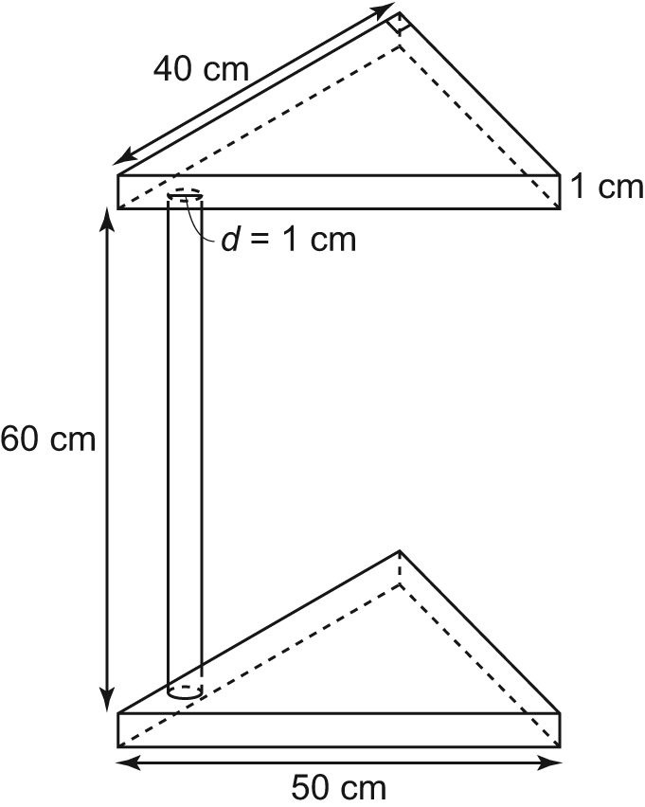Use the diagram on the right.

The triangular prisms are congruent.

Here is a student’s work to determine the surface

area of the composite object. Describe any errors and

show a correct solution.

Triangular Prisms:   
(4)()(40)(30) + 50(1)(2)

+ 30(1)(2) + 40(1)(2) = 2640

Cylinder:   
π(1)(60) = 188.5

Total surface area: 2828.5 cm24. The diagram at the right shows part of a platform   
for off-shore drilling.

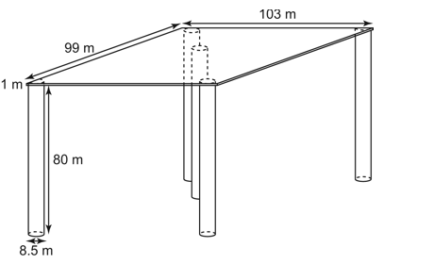 All the exposed surfaces (top and bottom)  
are to be prepared for use. Determine the   
surface area of the platform.