3.2 CELL DIVISION
Pgs. 46 – 48

3.2 Cell Division

MITOSIS
In multicellular organisms, the process that produces two new cells with the same number of chromosomes is called ______________________.
Mitosis: ___________________________________________________________ __________________________________________________________________.
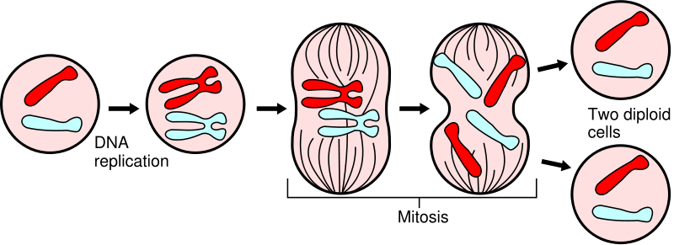

Purpose of Mitosis:
- _____________________________________________________________
- _____________________________________________________________
- _____________________________________________________________

So, if an amoeba had 6 chromosomes in its nucleus, how many will it have just before it splits in two? ________________

How many chromosomes will the divided cell have?
__________________________________________________________

MEIOSIS
During sexual reproduction, the __________________ (gametes) join to make a _______________, which make a new individual. The gametes only have _____________________________________________________and divide through meiosis.
Meiosis: ___________________________________________________________ _________________________________________________________. The female gamete, and male gamete combine to make a full set of DNA.

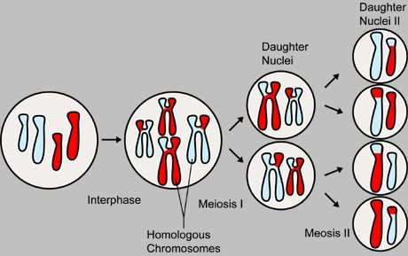
Meiosis
The purpose of ____________ is to produce sex cells (gametes: eggs and sperm).

Meiosis produces half the number of chromosomes as the original cell. Meiosis involves a reduction in the amount of genetic material, through ____ cell divisions.

The reason for the reduction is that only half the genetic information is needed to be passed on to the offspring. _________________________________________ __________________________________________________________________.

Complete the table to compare chromosome numbers in the species below.

