3.1 – What Is a Rational Number?

Natural numbers: the counting numbers (1, 2, 3, …)
Whole numbers: the counting numbers, plus 0 (0, 1, 2, 3, …)
Integers: positive, negative, or zero whole numbers (…, -3, -2, -1, 0, 1, 2, 3, …)
Rational numbers: numbers that can be written in fraction form - this includes decimal numbers that are infinite but have a recurring pattern
Ex.

Irrational numbers: numbers that cannot be written as fractions – in other words, decimal numbers that are infinite and patternless
Ex.

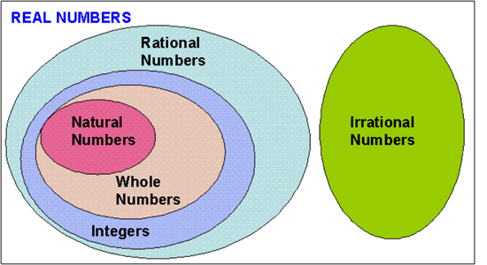

Ex. 1: Which rational number is greater?

- -3.2 vs. -3.26 (b) $\frac{5}{8}$ vs. $\frac{7}{12}$

(c) $-1\frac{2}{3}$ vs. $-\frac{7}{5}$ (d) 1.32 vs. $1.\overline{32}$

Ex. 2: Write the fraction represented by each letter.
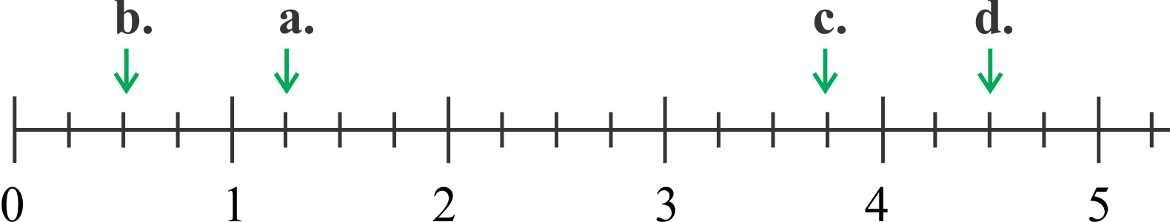

Ex. 3: Without using a calculator, order these rational numbers from least to greatest.

$$-\frac{3}{8} 1.3 \frac{5}{9} 0.\overline{7} -\frac{10}{4} -1\frac{1}{4} \frac{8}{3}$$

Assignment: ____________________________________________________________________________________________

