Compound Name | Elements in Compound | Number of total atoms | Drawing of Compound
CaO _{(s)}

CaCl_{2(s)}

Al₂O_{3(s)}

Na₂O_{(s)}

NaOH_{(s)}

SAMPLE PAT QUESTION
Use the following diagram to answer question 12.
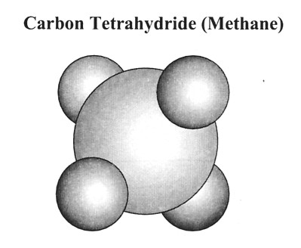

12. The chemical formula for the molecular compound shown above is
A. C₄H
B. CH₄
C. C₄H₃
D. C₃H₄

