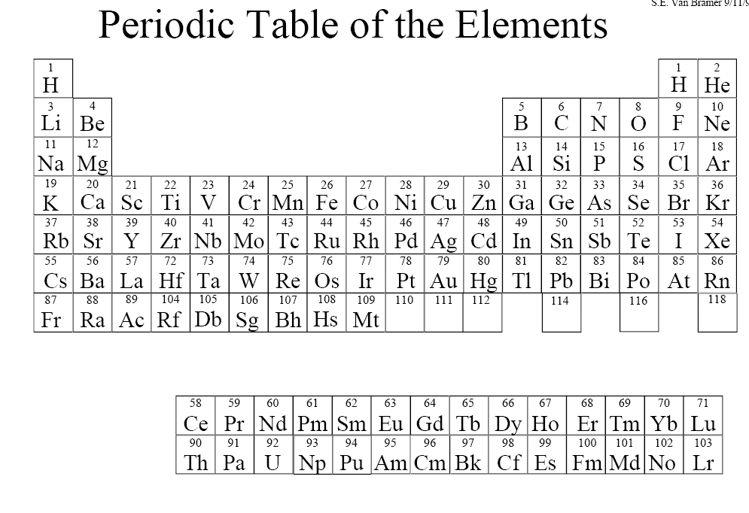

Periodic Table of the Elements Practice
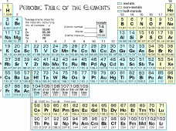

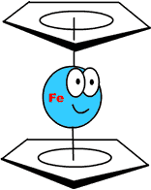

- On the periodic table colour the following items:
(in the blank below write the color you used,
Use a different color for each)
- metals: __________________
- non-metals: ______________
- metalloids: _______________

Describe the properties of each of the following:
a. metals: ___________________________________________________________________
____________________________________________________________________________
b. non-metals: ______________________________________________________________
____________________________________________________________________________________________________________________________________________________________________________________________________________________________________
c. metalloids: _______________________________________________________________
____________________________________________________________________________

2) Clearly identify the following items on your periodic table:

- groups
- families
- periods
- alkali metals
- alkaline-earth metals
- halogens
- noble gases

Answer the following questions ….

3) Where can you find the atomic number on the periodic table? What does it indicate? Give an example.

____________________________________________________________________________________________________________________________________________________________________
____________________________________________________________________________
4) Where can you find the atomic mass? Is it correct to say that the atomic mass tells you the total mass of all the protons, neutrons and electrons in an atom? Explain why or why not.
____________________________________________________________________________________________________________________________________________________________________
____________________________________________________________________________
5) Write a formula that could be used to find the number of neutrons in an atom.

6) Using the periodic table on pages 126 – 127, choose one unique element.
Copy it out below and label the following parts: name, symbol, atomic mass, atomic number, and ion charge.

SKILL PRACTICE P. 133
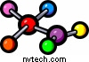

Use the periodic table in Toolbox 12 to answer the following questions.

1a) How many elements are gases at room temperature (20°C)? Write their chemical names and symbols.

- How many elements are liquids at room temperature (20°C)? Write their chemical names and symbols.

2. What element is found in group 2, period 3?

3a) What is the symbol of the element with the atomic number 82?

- What is the atomic number of arsenic?

4a) What is the symbol of the element with the atomic mass of 238?

- What is the atomic mass of silver?

5. Us the atomic number, atomic mass, and symbol of the elements to indicate the number of subatomic particles in an atom of the following elements: (show your work)

- electrons in oxygen

- electrons in Li

- protons in Na

- protons in helium

6. Two of the most recent elements to be discovered are ununbium and ununquadrium. Ununbium has an atomic number of 112 and an atomic mass of 277. Ununquadrium has an atomic number of 114 and an atomic mass of 289. What do you think the atomic mass of the element with atomic number 113 will be?

