Topic 2.1 Evolving Theories of Matter

Historical Timeline

Date | Scientist | Theory | Model | Analogy
400 B.C. | Democritus | Atomos Theory of Matter – all matter is composed of tiny indivisible particles
350 B.C. | Aristotle | All matter is composed of earth, wind, fire and water
1660 A.D. | Robert Boyle | Tiny particles group together in various combination to form all matter
1780 A.D. | Antoine Laurent Lavoisier | Father of modern chemistry - Developed a system for naming all matter
1794 A.D. | Marie Lavoisier | First female chemist continued the work of her husband in naming matter
1808 A.D. | John Dalton | Billiard Ball Model of Matter – Each element is composed of a particle called an atom with identical, unique mass. | Featureless Sphere | Billiard Balls  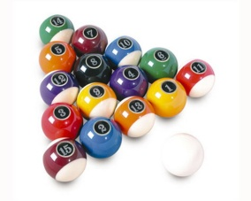
1897 A.D. | J.J. Thomson | Raisin Bun Model of Matter – Atoms are positively charged spheres in which negatively charged electrons were embedded like raisins in a bun | Uniform Charge distribution  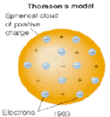 | Raisin Bun 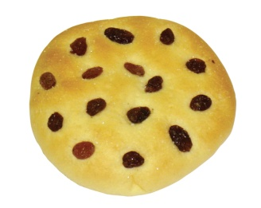
1904 A.D. | Hantaro Nagaoka | Solar System Model of Matter – Negatively charged electrons in atoms orbit around a large positive charge. | 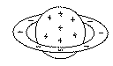  Flat ring of electrons | Saturn  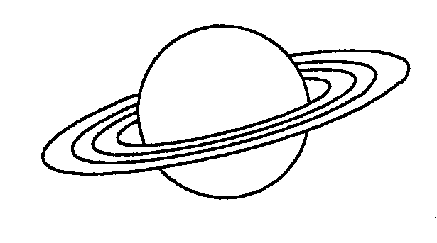
1908 A.D. | Ernest Rutherford | Atoms were mainly empty space with a tiny positively charged centre called a nucleus calculated to be about 1/10 000th the size of the atom | Nuclear Model  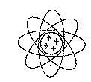 | 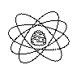  Beehive
1922 A.D. | Niels Bohr (Rutherford contemporary) | Electrons orbit in specific circular orbits or electron shells. Electrons jump between these shells by gaining or losing energy. | 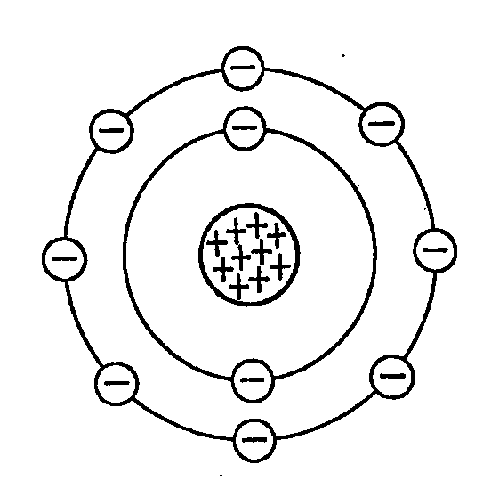 | 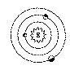
 | James Chadwick | Refined Bohr’s model of atoms suggesting that the nucleus of an atom was made up of positively charged particles called protons and neutrally charged particles called neutrons.
 | Quantum Mechanics Theory | Electrons probability orbital’s (wave patterns). A cloud of electrons surrounding the nucleus. | 