2.1 – What Is a Power?

A product of equal factors can be written as a ___________________________.
Ex: 5 × 5 × 5
We say:
5³
5 to the _________ ,
5 to the ___________________________________ , or
5 ___________________.

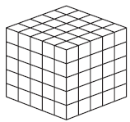
NOTE: _________________ and ______________ numbers are numbers that can be written as a power with an integer base and exponent 2 or 3, respectively.
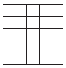
Ex.

Ex. 1: Write the following as powers.
- 3 × 3 × 3 × 3 × 3 × 3 × 3
Note: The base is the number that is multiplied over and over. The number of times it is multiplied over and over is the exponent.

- 7

- -(-9)(-9)(-9)(-9)(-9)

Ex. 2: Write as repeated multiplication and in standard form.
- 4³
When you evaluate the power to get the number it represents this answer is said to be in standard form.

- (-2)⁵

- -7⁴

Ex. 3: Identify the base of the power and evaluate.
- (-3)⁴

- -3⁴

- –(-3)⁴

- –(-3⁴)

Ex. 4: Why do (-2)³ and -2³ give the same answer?

