Matter and Chemical Change
Sec. 1.2 - Organizing Matter

Matter exists as a solid liquid or gas.
Three states of matter!
1. ___________________
2. ___________________
3.___________________
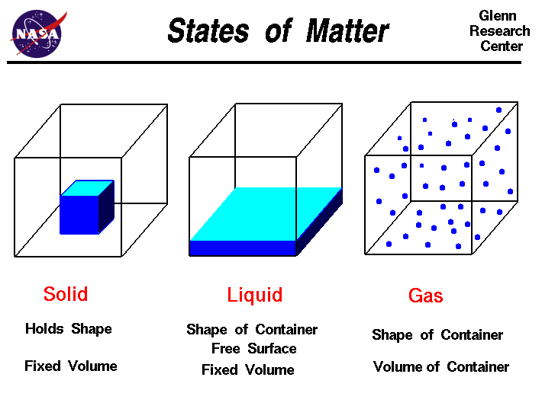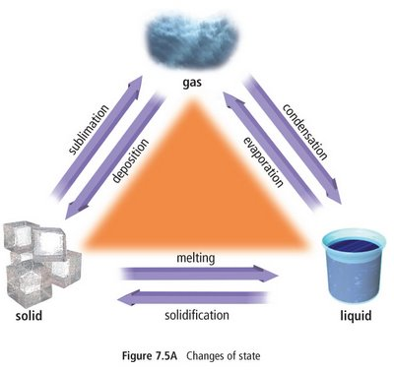
See page 97

Physical Properties
Definition: | Examples:

Physical Change
Definition: | Examples:

Chemical Properties
Definition: | Examples:

Chemical Change
Definition: | Examples:

Pure Substance or Mixture?
Pure substance is made of only one kind of matter and has a unique set of properties that sets it apart from any other kind of matter.
A pure substance may be either an element or a compound.
Element – _______________________________________________________________
Compound – _____________________________________________________________

A mixture is a combination of pure substances.
Four types of mixtures
Mechanical mixture: _______________________________________________________
Solution: ________________________________________________________________
Suspension: ______________________________________________________________ ________________________________________________________________________
Colloid:__________________________________________________________________ ________________________________________________________________________

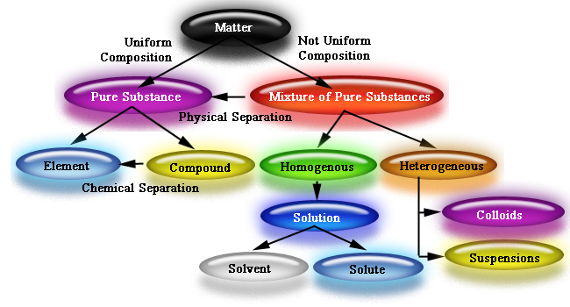
Assignment: Page 104 # 2-5, 7, 8

