1.2 – Pythagorean Theorem
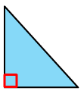
Review: Right Triangles – A triangle with a 90 degree angle. Label it!

The area of a triangle is found by:
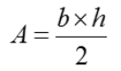

The ______________ is the longest side.

Pythagorean Theorem
The Pythagorean Theorem works only with Right Triangles.
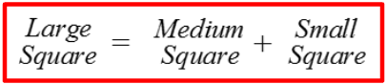
Rule: Each side of the triangle is used to make a square.
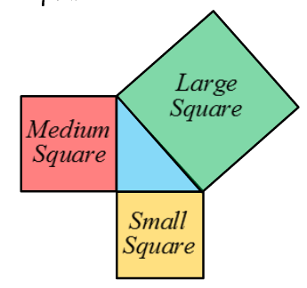
Pythagorean Rule: a² + b² = c²
Naming the sides or a right triangle: Rule:

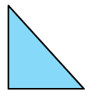
a: base or height
b: base or height
c: ___________________

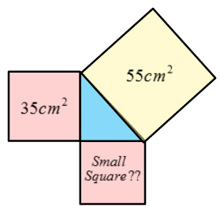
Example: Find the area of the missing square:
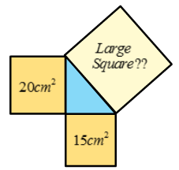

Sides of a Right Triangle
To find the length of a missing side
- Get the area of all 3 squares
- Square root the area of the square to find the length of the side
Ex. Find the length of AC given the other sides
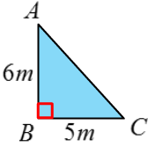

Practice: Find the missing side.
