Symbol Shapes

Colour: _____________________ Colour: _____________

Means: _____________________ v Means: ______________

Colour: _____________________

Means: _____________________

Common Hazard Warnings

Means: __________________ Means: _________________

Means: __________________ Means: _________________

Means: __________________ Means: ________________

Means: __________________

WHMIS:

Means: ________________
Means: __________________

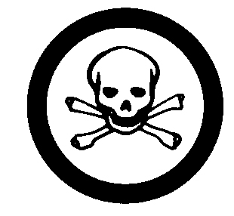
Means: ________________
Means: ________________
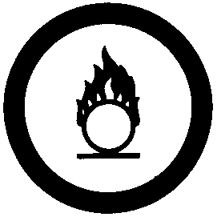

Means: ________________
Means: _______________

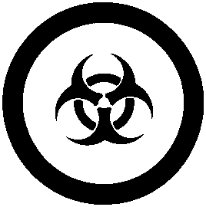

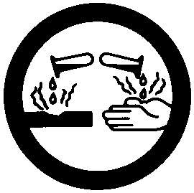
Means: ________________
Means: _______________

Lab Safety Rules Review
(Student book page 95) 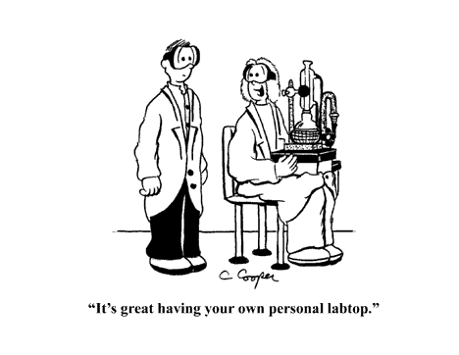
Safety is paramount in a science laboratory. Use these review questions to ensure that you completely understand what is expected of you.
1. If you place chemicals into a container, what should you do to the container?
_________________________________________________________________________
_________________________________________________________________________
2. What does the acronym WHMIS stand for?
_________________________________________________________________________
3. How should you go about detecting the odour of a substance?
_________________________________________________________________________
_________________________________________________________________________
4. What should you do with long, loose hair and sleeves?
_________________________________________________________________________
_________________________________________________________________________
5. What should you do after handling any chemicals?
_________________________________________________________________________
_________________________________________________________________________
6. What should you do with cracked or broken glassware?
_________________________________________________________________________
_________________________________________________________________________

UNIT B—MATTER AND CHEMICAL CHANGE

Answers to Lab Safety Rules Review

1. Close containers immediately after using them.
2. Workplace Hazardous Materials Information System
3. Never smell any substance directly. Instead, gently wave your hand over it to bring its vapours toward your nose.
4. Tie back long, loose hair. Roll up long sleeves.
5. Always wash hands well with soap, preferably liquid soap.
6. Handle all glassware carefully. Ask the teacher how to dispose of broken glass properly.

Check and Reflect (page 96)

1. Why is it important for all students to follow the safety rules while in a science class?
__________________________________________________________________________
__________________________________________________________________________
__________________________________________________________________________
2. Why is there a need for a WHMIS program?
__________________________________________________________________________
__________________________________________________________________________
__________________________________________________________________________
3. On area of special consideration for people working in a lab is understanding warning labels. What is the other special consideration?
__________________________________________________________________________
__________________________________________________________________________
__________________________________________________________________________
- What does each hazard warning label mean on the chemicals shown on the following cans?
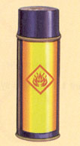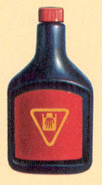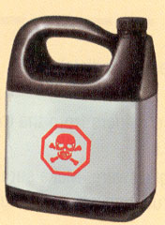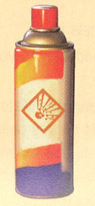
a b c d

a) _______________________________________________________________________
b) _______________________________________________________________________
- _______________________________________________________________________
- _______________________________________________________________________

- What type of WHMIS symbols would you expect to see on the following containers?
a. a can of gasoline: _____________________________________
b. a tub of caustic cleaning chemical: _______________________________
- a bottle of oxygen gas: ___________________________________
- a bottle of sulfuric acid: __________________________________

6. Explain the difference between WHMIS symbols and safety symbols used on commercial products.
__________________________________________________________________________
__________________________________________________________________________
__________________________________________________________________________
7. List the steps a student should take before starting a science activity where safety is an issue.
__________________________________________________________________________
__________________________________________________________________________
__________________________________________________________________________
8. Describe one problem that may occur with having different coloured safety symbols.
__________________________________________________________________________
__________________________________________________________________________
__________________________________________________________________________
9. What additional lab safety rules would you add to the list on page 95?
__________________________________________________________________________
__________________________________________________________________________
__________________________________________________________________________

